

Radiography Program Student Handbook

2026-2027

Table of Contents
Introduction 2
Mission Statement/ Program Goals/ Student Learning Outcomes 2
Electronic Bulletin Boards 3
Campus Emergencies / Myctstate Alerts 3
Attendance / Illness / Injury Policies 3
Withdrawal 5
Program Severance 6
Re-Entry Into The Radiography Program 6
Grading Policies 7
Program Curriculum 9
Clinical Education 10
Guidelines For Clinical Supervision Of Students 13
Unsafe Clinicals 14
Dress Code 15
Learning Resources 16
Remediation 17
Radiology Lab/Classroom 17
Allied Health Computer Lab 18
Radiation Protection 18
Pregnancy 19
Cell Phones 21
Infectious Disease/Bloodborne Pathogen 21
Communicable Diseases 22
Inclement Weather 22
Academic Integrity And Plagiarism 23
Substance Abuse 23
Student Complaints/Academic Appeal /Jrcert Standards 24
Student Responsibility/Recording Lectures 25
The American Registry Of Radiologic Technologists 26
Connecticut State License 27
Extra-Curricular Activities 27
Professional Conferences, Lectures And Scientific Articles 28
Student Records 28
Exams And Quizzes 28
Library Facilities 28
Parking Facilities 29
Essential Requirements 29
Tips For Success 29
Program Documents/Forms And Clinical-Related Materials 31
Criteria For Clinical Competency Evaluation 10
Appendix A. Student Health Requirements 15
Appendix B. Program Technical Standards 17
Appendix C. Procedure For Reporting Injuries 18
Appendix D. Program Grading System (Trajecsys/Typhon) 20
Appendix E: Declaration Of Pregnancy 21
Appendix F: Pregnancy Guidelines 22
Appendix G: Revoking Declaration Of Pregnancy 24
Appendix H: Pre-Clinical Mri Screening Form 25
Appendix I. Process For Changes Made To Policies 27

INTRODUCTION
The students in the Radiography program are expected to refer to the college catalog, student handbook and the Radiography program student handbook for guidance and information about the program.

MISSION STATEMENT/ PROGRAM GOALS/ STUDENT LEARNING OUTCOMES

Mission Statement
The mission of the CT State Community College radiography program is to provide a comprehensive radiography program that will graduate competent, entry-level radiologic technologists for the healthcare community.

Program Learning Outcomes
*Based on JRCERT accreditation standards

Upon completion of this program:

Goal 1: Students will demonstrate effective communication skills
Student Learning Outcomes:
- Students will use effective oral communication skills with a wide variety of audiences in the clinical setting
- Students will practice effective written communication skills

Goal 2: Students will utilize critical thinking skills
Student Learning Outcomes:
- Students will assess images for diagnostic quality
- Students will assess images and make appropriate adjustments as needed

Goal 3: Students will be clinically competent when performing entry-level imaging procedures
Student Learning Outcomes:
- Students will accurately position patients for radiographic procedures based on patient assessment
- Students will select appropriate technical factors to obtain diagnostic-quality images based on patient assessment
- Students will utilize radiation safety for themselves and others

Goal 4: Students will demonstrate professional behavior
Student Learning Outcomes:
- Students will demonstrate professionalism in the program
- Students will participate in professional activities with state and national organizations

ELECTRONIC BULLETIN BOARDS
Electronic Bulletin boards serve as a medium for the communication of important notices. The bulletin board/whiteboard located in the radiography program classroom should be checked on class days for important notices and information.

CAMPUS EMERGENCIES / MYCTSTATE ALERTS
CT State Naugatuck Valley has an emergency activation system. Campus emergencies may be announced over the phone speakers in classrooms. Emergency and campus-closing notifications for inclement weather or other situations will be sent via text to students’ cell phones. Students are strongly encouraged to register for myCTState alerts.

ATTENDANCE / ILLNESS / INJURY POLICIES
Radiology students will enhance their education by attending all scheduled classes and clinical practice. Attendance plays a vital role in meeting the mission/objectives of this program, in graduating competent students who meet the entry-level requirements to help them obtain a position in this profession. Attendance/punctuality is important since class lectures establish the objectives, instructions and learning experiences for the day. Instructors cannot repeat an entire lecture for a latecomer. Absenteeism for emergencies, accidents or illnesses requires evaluation by the program director/coordinator (the program official) of the radiography program. Only a program official can determine whether students will attend clinical or leave early. Instructors and preceptors cannot grant special privileges to students on their own, except in extraordinary circumstances or emergencies. They must contact a program official for approval. Students who do not receive permission, as outlined above and leave early or do not show up for clinical as assigned can be considered as unethical behavior. Students will therefore need to meet with the program director and/or clinical coordinator to determine the circumstances for these actions. This could lead to dismissal from the program.

Excessive class and clinical misses adversely affect the learning experiences. Students with excessive absences may not meet the program's educational objectives. It is the student's responsibility to communicate with the instructor about any information or class content missed due to absence. Withdrawal from the program can occur. Students may be placed on probation for violation of the program attendance policy. This attendance policy is clearly laid out below.

- Every class and clinical session offers the student an opportunity to learn. Therefore, students are expected to attend all scheduled classes, clinical and conferences. In the event of an illness, students are allowed two occurrences (absences, tardiness and/or leaving early) from class and two from clinical during the fall and spring semesters. Students are allowed only one occurrence (absences, tardiness and/or leaving early) from class and one from clinical in the summer session. Excused absences are not given for students to take time off, but rather to provide flexibility in the event of illness. Since one never knows when an illness will occur, faculty encourage students to attend all classes and clinical as scheduled.
Tardiness, not attending conferences, leaving early and absenteeism are all considered when reviewing students’ participation in the program. A combination of these issues can result in a student being placed on probation or a faculty-initiated withdrawal from the program. Unless there are extenuating circumstances, a combination of any two occurrences will result in a written warning and the student will be remanded to meet with a program official. Any further occurrences will require a doctor’s note; if one cannot be provided, students will lose one full letter grade for each occurrence. Any illness or injury that results in the student having an excessive number of absences may result in the student's dismissal if the educational objectives are not met. DO NOT ABUSE SICK TIME. Every situation is considered on a case-by-case basis.
- If the unfortunate event of an illness occurs and if the student exceeds their two occurrences and they are allowed to continue in the program, they must make up all clinical time missed after two sick days are used. The director schedules the make-up time. All sick time over the two days must be made up prior to the start of the next semester and in accordance with the schedule established by the program director.
- A student missing an entire clinical rotation may be required to make up at least, but not restricted to, one day of that experience, even if the time missed does not exceed the two allowed absences. It is not the room that is the assignment; rather, it is the skill and objective that are considered. All are considered on a case-by-case basis.
- Good attendance and on-time arrival for scheduled assignments are professional traits employers seek when hiring radiographers. All missed clinical time affects your grade. As stated above, missed clinical is defined as being absent for the entire day or part of the day, arriving late for clinical, leaving early and not attending conferences. Each of the preceding is considered an occurrence and will be indicated on the student’s clinical evaluation.
- When a student is absent from clinical, they are required to call their clinical instructor and, when applicable, the affiliate, to report the absence. The call is to be made by 8:30 a.m. Failure to call is considered an unexcused absence, and the student will make up the time missed. If an affiliate is unavailable to take the call, the student should call either the program director or the clinical coordinator. Both instructors have voicemail.
- Punctuality/tardiness is required since it affects the health and safety of the patients. It is disruptive to the patient exams when a student who is late for clinical reports is in the middle of the procedure. Promptness is an ethical trait that most employers seek in a new employee. There are many procedures in which patients have undergone preparation for the procedure. Some patients have taken time off from work and will be returning to their jobs upon completion of the exam. These patients would like to complete the exam promptly and without delay. Tardiness may disrupt the procedure. On the first two occurrences, the student is late, the instructor will issue a verbal warning as outlined above in bullet a of this section as well as any further concerns with punctuality. All incidents of tardiness will affect the student's clinical grade, regardless of any time made up.
- Excessive misses/punctuality or any abuse of the attendance policy from class or clinical will be considered on a case-by-case basis. A student who habitually violates the attendance policy will be withdrawn for failing to meet the educational objectives of the program. Habitual violation is defined as more than two offenses, with a warning for those offenses during the program.
- Students who sustain injuries or experience a sudden illness during clinical practice must report all injuries to the clinical instructor. (See procedure and form located in Appendix C).
- Students who have an illness or are fatigued should use caution when reporting for clinical. Remember, patients are weak. It is not in the patient's best interest to be exposed to other diseases. Students who are fatigued are also putting patients at risk. Fatigue affects one's cognitive abilities. Students who are ill or tired may be sent home by the instructor. The clinical instructors will be guided by the policies of the affiliates. (See Communicable Diseases section for further information.)
- Any change in the student's health status requires notification to the clinical coordinator and the Office of Disability Services. This includes any medication the student may be taking. Remember, many medications can impair movement, judgment, thinking and vision. A student on medication may not practice safely. Each case will be considered on an individual basis, and many require consultation with the student's physician and the submission of medical reports.
- The radiography program does allow students to observe religious holidays. The student should contact the program director to request time off to observe a religious holiday. Missed clinical time may need to be made up, depending on the amount of time the student misses. This is determined on a case-by-case basis.

WITHDRAWAL
- Faculty may request the withdrawal of a student having an unsatisfactory academic and clinical record. Students can be withdrawn at any time if they are determined to be clinically unsafe. A student who is withdrawn for unsafe clinical is also withdrawn from the radiology class. The student will be given a grade of W for the class. (See Section 10 for unsafe clinical)
- The faculty may request the withdrawal of a student having excessive absenteeism or tardiness.
- The faculty may request a student's withdrawal for improper conduct in the classroom or clinical setting, including, but not limited to, academic dishonesty.
- The faculty may request a student’s withdrawal for repeated violations of the dress code.
- The faculty may request the withdrawal of a student who does not maintain either patient or affiliate confidentiality. (An affiliate is any facility that accepts students for educational or clinical experiences)
- Clinical affiliates have the contractual right to request that the program remove a student from their facility. Reasons a student may be removed include, but are not limited to, breach of patient confidentiality (HIPAA), breach of (FERPA), possession of business documents outside the facility, theft of hospital property/supplies, improper use of cell phone, disruptive/rude behavior with patients and /or staff, argumentative behavior and interfering with patient throughput. The removal of a student from a clinical affiliate may well result in dismissal of the student from the program.
- Upon withdrawal from the program, you are to return the dosimeter badge and hospital IDs. Failure to do so affects your withdrawal status, especially if you leave in good standing.
- Documented medical reasons that require an extended time period for recovery (ex. therapy or the achievement of a medication level) may result in the withdrawal of the student, regardless of the amount of course time that the student has completed. Every situation is different and considered on a case-by-case basis. Faculty will be guided by the time available between semesters as well as the ability of the student to complete the educational objectives prior to the start of the next semester. When possible, faculty will make every attempt to provide reasonable accommodations for the student with a documented illness. Medications that interfere with cognitive and psychomotor abilities will prevent the student from completing the course and will result in withdrawal.

Voluntary Withdrawal
Students desiring to withdraw voluntarily from the radiography program should write a letter to the program director to clarify their status and records. An exit interview will be scheduled with the program director upon receipt of the resignation.

The academic calendar specifies the last date by which a student may initiate withdrawal from a course. A student who remains in the program past the student-initiated withdrawal date will be given the grade they have earned. Any assessments missed because of withdrawal after the deadline will be factored into the calculation of the final course average. For example, a student withdraws after the deadline and does not take the final exam. The grade for the final would be 0 and averaged as outlined in the course syllabi.

PROGRAM SEVERANCE
Students are permanently severed from the radiography program without the possibility of readmission in the following circumstances, but not limited to:
- A student who, in the professional judgment of program officials or clinical affiliates, demonstrates inappropriate, unethical or unsafe behavior or who places a client/patient or anyone else in imminent danger, may be removed immediately from the classroom, laboratory or clinical assignment, in violation of the code of conduct, HIPAA and FERPA violations.
- Violation of the attendance policy (see Attendance/Illness/Injuries section) may also result in program severance.

RE-ENTRY INTO THE RADIOGRAPHY PROGRAM
Students may re-enter the Naugatuck Valley radiography program only once through reapplication or readmission.

Reapplication
Students who withdraw from, do not successfully complete or are dismissed from their first semester must reapply to the program to be considered for admission for a second time. Reapplication means submitting a new Naugatuck Valley radiography application to the program and going through the admissions process. Reapplying and being admitted a second time are considered a re-entry and count as the one-time re-entry to the program.

Readmission
Students who have successfully completed the first radiography semester may request readmission to the program. Readmission means seeking re-entry into the program to repeat the last radiography course(s) attempted. Students must have successfully completed at least the first semester of the program. Readmission is considered a re-entry to the program and counts as the one time a student may re-enter the program. Readmission is not guaranteed.

Students who have withdrawn due to personal, medical or academic issues in coursework other than clinical will be considered in good standing and may apply for readmission. A student withdrawn for unsafe clinical or academic dishonesty will not be allowed readmission (see program Section 8 Program Severance). A student who has demonstrated poor clinical progress and initiates a student withdrawal prior to the last date of student-initiated withdrawal will be considered on a case-by-case basis in terms of Re-Entry.

Procedure for Readmission
Students are to request in writing readmission into the program. For readmission into the fall semester, requests should be submitted by the end of spring semester of that year. Readmission into the spring semester requires the student to submit their written request no later November 1 of the previous semester. Students withdrawn for medical reasons may be required to submit physician reports clarifying their health status.

GRADING POLICIES
An explanation of semester hours and academic load is stated in the CT State catalog.

Faculty does not curve grades nor allow students to do extra credit assignments. The grading system used by program faculty is as follows:

Average | Grade
94.5 - 100 | A
89.5 - 94.4 | A-
86.5 - 89.4 | B+
83.5 - 86.4 | B
79.5 - 83.4 | B-
76.5 - 79.4 | C+
73.4 - 76.4 | C
69.5 - 73.3 | C-
66.5 - 69.4 | D+
63.5 - 66.4 | D
59.5 - 63.4 | D-
59.4 and below | F

A student must maintain a grade of C in radiology theory, clinical and the three general education sciences to remain in the program.

Grades assigned to students by program faculty are a summary of the instructor’s evaluation of the learning achieved by the student as outlined by the educational objectives defined in the course syllabus. Each course has objectives written in the cognitive, psychomotor and affective domains.

The radiology program uses a competency-based grading system. This means that by passing a course, the student has demonstrated competence. Competence is the ability of the student to demonstrate a skill or knowledge that is consistent with the standards and abilities required of an entry-level radiographer. In radiology class work, a grade of “C” designates competence. In clinical an overall final average of “C” in ALL evaluated areas indicates competence. In addition to the overall average, each clinical competency examination requires a minimum of an 80 for successful completion of a particular radiologic procedure.

Clinical Grading
The student must receive a satisfactory clinical evaluation (grade of "C") to remain in the program and progress to the next semester in radiography. The criteria for satisfactory performance are as follows:

- 50% of Clinical Competency
- 40% of Professional Behavioral/Clinical Skill Evaluation Grade
- 10% of Clinical Quizzes/Exams (if applicable)
If there are no clinical quizzes, then grade is based on 50% competency and 50% clinical skill evaluation.

EXAMPLE 1-Passing
Clinical Competency Average 73.4 or above
Test/Quiz Average 73.4 or above
Behavior/Skill 73.4 or above
Final Average 73.4 or above

Students must achieve an average of 73.4 or above in each of the three categories identified above to demonstrate competence. An average of less than 73.4 in any one category will result in withdrawal, even if the total average is passing. Students must remember that competence is to be achieved in all areas.

EXAMPLE 2-Not Passing
Clinical Competency Average 89
Test/Quiz Average 70.6
Behavior/Skill 85
Final Average 81.5

In the “Not Passing” example above, the student has not successfully completed the clinical course despite the 81.5 average because they had a 70.6 average in tests/quizzes. The student will not be able to progress in the program.

The required minimum number of clinical competencies is to be completed on time. Failure to satisfactorily complete the competencies will result in the withdrawal of the student. Failing to complete all required competencies may result in a student being declared not registry eligible. Complete all competencies when possible. Clinical faculty will document students who decline to perform competencies or do not aggressively pursue procedures. The college and faculty are not responsible for a student who does not complete all competencies in the 22 months, especially when the student has declined procedures.

As previously stated, successful completion of a clinical competency requires a minimum grade of 80. Students not successfully completing a competency may be given two additional opportunities to complete the competency. A student not successfully completing a competency after three attempts is withdrawn from the program. The first grade earned is used to calculate the clinical average. The number of competencies to be completed is identified each semester. Faculty will review the purpose of a competency-based education and the evaluation process during orientation. Failure to complete at least one assigned competency (each semester) with a grade of 80 or better will result in withdrawal, and the student will be issued a grade of F.

The student's progress in the clinical area will be reviewed at intervals and at the end of each term. The student who receives an unsatisfactory clinical warning is expected to seek an immediate conference with the director of the radiography program to develop a Performance Improvement Plan (PIP) and to help improve their clinical performance. Remedial help is available for students. It is the student’s responsibility to seek assistance or clarification.

For qualification as an ARRT Registry eligible, written exit competencies must be successfully completed with a minimum grade of 75. Students who do not achieve a minimum grade of 75 will receive an incomplete for the course and will no longer be eligible to sit for the ARRT exam. Students will be allowed to retake the written exit exam two times. If the student is unsuccessful on the third attempt, the course grade will be changed to “F”.

Instructors may also give grades of “I” for incomplete. An incomplete is given in extenuating circumstances, such as missed clinical time not made up. ALL incomplete grades must be satisfactorily completed according to program policy and requirements prior to the start of the next semester. Failure to meet all requirements will result in a grade of “F” and withdrawal from the program. An F grade will be given when a student is withdrawn from the program for unsafe clinical practice.

PROGRAM CURRICULUM
The program is structured in a sequential learning pattern. All courses must be taken in the order outlined in the program's curriculum and successfully completed by the assigned semester. General education courses may be taken earlier. Any change in the order can result in dismissal of the student from the program. Registration for the appropriate classes as outlined is required. Meet with your faculty advisor each semester to avoid taking the wrong class. It is possible that a student could get to the end of the program and discover they took the wrong class or are missing a class. This can prevent the student from graduating and sitting for the registry. ARRT rules require the applicant sit for the registry after completing all terminal degree requirements. If you have questions concerning your courses, please confer with your faculty advisor. Check the college catalog to ensure your elective meets the college core requirement.

Students are urged to register and pay for classes on time. This will avoid not getting the class or schedule that best fits your studies. It will also prevent the computer system from removing you from a section for non-payment.

CLINICAL EDUCATION
- Students are required to maintain a satisfactory and safe level of clinical practice at all times. Radiography students will be supervised at all times by a qualified staff technologist (radiographer), either directly or indirectly, as outlined in the Clinical Supervision section of this handbook. A qualified technologist (radiographer) is defined as a technologist (radiographer) who is certified by ARRT in radiography and holds a current license in radiography with the State of Connecticut D.P.H.
- Students are to report promptly for their clinical assignments in the morning and when returning from lunch and breaks. The earliest the student may report to clinical is 20 minutes before the scheduled start time. Students are to be in their assigned rooms at 8 a.m. Students should not go to clinical affiliates to visit with staff who are working.
- Students are expected to practice proper hand hygiene and follow standard precautions at all times. Hands are to be washed before and after every case. Patients will find it comforting to see the student wash their hands in front of them at the start of the case.
- Lunch and breaks are to be taken with permission of the clinical instructor or technologist.
- Students are to maintain patient confidentiality at all times. The unauthorized reading of a patient's chart, viewing of images or discussion of their illness/history is a violation of the Patient's Bill of Rights and HIPAA. Violation of confidentiality can result in dismissal from the program and is punishable by a term of imprisonment, a fine, or both. Patients' personal medical information is confidential. This includes name, date of birth, diagnosis, prognosis, procedures performed and treatments. The basic rule to remember for patient confidentiality is that if you learned it during your clinical experience, you cannot discuss it. This includes patients that you personally know. Possession of clinical affiliates’ documents and property outside of the site is grounds for dismissal.
- There are several clinical affiliates. Students will be assigned to the affiliates by the clinical coordinator. Please do not disrupt the workflow at the affiliates. They have generously allowed you to attend. Disruptive behavior can ruin an entire affiliation for everyone.
- Students are guests of the affiliate and are subject to all their rules and regulations, including parking and smoking policies. Several affiliates have smoke-free campuses. The affiliate's business is confidential and should not be discussed at other clinical facilities. Breaching affiliate business is grounds for dismissal from the program.
- No student is permitted to participate in any strike or job action while at the clinical facility. If at any time there is a strike or job action, the student is to check with program faculty for further instructions.
- Students must record performed clinical procedures in Trajecsys or Typhon clinical logs.
- Students are required to use/order anatomical side markers from the vendor approved by the program. This ensures consistency among students and assists affiliates in recognizing that the marker is a student marker. Only markers purchased from the program’s specified vendor are allowed.
- Students are not allowed to have more than 40 hours per week of class time and clinical contact. Students wishing to put in extra time are to receive permission from the director. Extra time may only be done during the semester and when an instructor is assigned.
- A staff technologist must check all radiographic procedures before the patient is discharged or the images are sent to PACS. The name of the technologist who approved the case is to be documented in accordance with facility policy for affiliates that allow student access to the medical record.
- Recording of procedures in the clinical record is done using the medical record number, charge number or exam number. The codes found in the clinical logs are to be used as outlined.
- All repeat radiographs are to be done under the direct supervision of a technologist, even if you have demonstrated competence. Any procedure in which the student repeats a radiograph is to be documented in the clinical record book. Above the exam performed the student is to write R = technologist's initials.
- Any student found to performing a repeat without technologist supervision will be given a written clinical conference slip. If, during the program, a student has a second occurrence of repeating a procedure without technologist supervision the student will be immediately withdrawn from the program. There are no exceptions. In the event a technologist instructs you to repeat without supervision the student is to politely refuse and immediately seek assistance from their clinical instructor.
- The level at which the student participated in the radiographic procedure is to be recorded as outlined in the clinical record book. The supervising technologist’s initials are recorded. All mobile exams must be done with a technologist.
- Students are not allowed to bring other school materials to clinical. Studying for other classes while in clinical is not appropriate. Only clinical material may be brought to the affiliates.
- Students should remember that faculty will be teaching according to the accepted standards, the Scope of Practice and the Code of Ethics. Faculty have different approaches and methods for performing procedures. The variety of approaches benefits students as it provides them with an opportunity to evaluate various approaches to imaging. Regardless of the methodologies instructors use, the goal is always to perform radiographic procedures within acceptable standards of practice, considering safety, efficiency and compassion. Students are to practice according to the instructions received from the faculty and are encouraged to seek clarification from instructors (not in front of patients or staff) when conflicts or questions occur while performing radiologic procedures. The instructor has the final say in all matters concerning the performance of procedures. The instructors’ expertise should be utilized to the maximum capabilities for a rewarding clinical experience.
- Students may be given the opportunity to be employed at one of the program’s clinical affiliates or at another imaging facility as a technical assistant or aid. Any experiences the student participates in or receives while employed cannot be counted towards the program’s educational experiences. Work and school are two distinct, separate entities. The program and college assume no responsibility for the student during employment.
- Students will be given their clinical assignments at the start of the semester. If someone calls the assignment looking for a student, the faculty will take the call, not the student. Faculty WILL NOT confirm you are at that location. They may, at their discretion, take a message and notify the caller that they will attempt to locate you. If they choose not to take a message, the caller will be referred to campus police. Campus police will then attempt to locate the student. This is required by college policy under the federal privacy acts. If this is unacceptable to the student, it’s recommended that the student consider providing their clinical instructor with a written release that states the instructor may inform a caller that you are assigned to that location. The written release must be submitted every semester to the clinical instructor. Remember, cell phones are not allowed during clinical experiences. Therefore, a phone that must be answered in a clinical setting is unacceptable.
- Problems with hospital employees are to be brought to the immediate attention of the clinical instructor. DO NOT CONFRONT OR ARGUE WITH ANY HOSPITAL EMPLOYEE.
- Students should use professional discretion when questioning actions or decisions. NEVER ARGUE WITH STAFF, CLASSMATES OR FACULTY IN THE PATIENT CARE AREA.

MRI Safety Policy
All students are required to complete MRI safety education and an MRI safety screening form at designated points in the program to ensure compliance with established safety standards.

First-Year Students
Prior to beginning their initial clinical rotation, first-year students must complete basic MRI safety training and submit an MRI Safety Screening Form. The program will review the form before the clinical start date and notify students if any additional steps or documentation are required. During this training, students are instructed that they are not permitted to enter MRI suite zones 3 or 4 under any circumstances.

Second-Year Students:
Because students may be assigned to MRI rotations during their second year, they must complete updated MRI safety education and submit a new MRI Safety Screening Form. These forms will be reviewed by the clinical coordinator and/or program director before any MRI clinical assignment is made.

Change in Status
All students, regardless of year, are required to inform the program immediately if any changes occur that would alter the information provided on their previously submitted MRI Screening Forms (e.g., implants, devices, injuries or other MRI-relevant conditions). ***MRI Screening Forms will be handed out as applicable***

CEU attendance/conferences may be considered by program officials as extra time earned clinical hours, which will be based on the following criteria: (1CEU = 1 clinical hour/ a maximum of one full day/per semester), CEU events must be approved before attendance, and proof of attendance is mandatory.

GUIDELINES FOR CLINICAL SUPERVISION OF STUDENTS

POLICY
Radiography students will have the supervision of a qualified staff technologist (radiographer) at all times, through direct or indirect supervision as outlined in the procedures below. A qualified technologist (radiographer) is defined as a technologist (radiographer) who is certified by ARRT in radiography and holds a current license in radiography with the State of Connecticut D.P.H.

PROCEDURE
Each student will be assigned to work under the direct or indirect supervision of a qualified staff technologist (radiographer).

CLINICAL STAFF DIRECT SUPERVISION
A student must have direct supervision while observing, practicing or performing an exam in which he/she has not yet attained competency. Direct supervision is defined as a licensed and registered radiography technologist overseeing all activities associated with that radiographic procedure, including:
- The qualified radiographer reviews the procedure in relation to the student’s current level of expectation.
- The qualified radiographer evaluates the condition of the patient in relation to the student’s knowledge.
- The qualified radiographer is present during the conduct of the procedure.
- The qualified radiographer reviews and approves the procedure and positioning.
- In order to maximize radiation protection, all unsatisfactory radiographs must be repeated under the direct supervision of licensed technologists.
- In order to maximize radiation protection, clinical safety and patient safety, all OR/C-Arm based procedures and portable radiographs must be performed under direct supervision.

A qualified technologist is defined as a state-licensed and ARRT-registered technologist.

If a student technologist repeats an image(s) without a qualified technologist present, the clinical instructor will notify the clinical coordinator, who will meet with the student to implement disciplinary actions.

CLINICAL STAFF INDIRECT SUPERVISION
After a student has attained competency in a particular exam, then he/she may perform that exam with Indirect Supervision. Indirect Supervision is defined as a qualified radiographer immediately available to assist a student, regardless of the level of the student’s achievement or competency. Immediately available is interpreted as the presence of a qualified radiographer adjacent to the room or location where a radiographic procedure is being performed. This availability applies to all areas where ionizing radiation is in use.
Created: 9/19/17
Reviewed: 11/06/17, 02/20/18, 08/08/19, 08/17/20, 07/28/21, 07/27/2023, 08/22/2024, 8/23/2025, 08/14/2026
Revised: 10/01/2026

UNSAFE CLINICALS
During clinicals, instructors will be working with each student, evaluating their clinical skill level. As a result of faculty observations, a student may be identified as being unsafe during clinical practice. Unsafe clinical includes, but is not limited to, poor radiation protection/shielding, failure to document/question the possibility of pregnancy, high number of radiographic repeats, performing wrong radiologic procedures, improper standard precautions and improper or lack of use of anatomical side markers. Based on their observations, the faculty will complete a Student/Faculty Conference Form identifying the incidents. The student will be required to confer with the program director.

Faculty will give clinical warnings if the student cannot consistently demonstrate skills or meet the expected educational objectives. Repeated warnings can place the student on a probationary status. Probationary status indicates to the student that another omission of the same skill, error or a repeat of the behavior/violation of program policy will result in withdrawal. Students receiving a warning should confer with the faculty and program director to develop a plan for remediation. A student will not be on probation or given a warning without their knowledge. A student who receives a warning for unsafe clinical is to seek immediate assistance from the program’s retention and remediation specialist.

Students should remember that the observations of the faculty are based in their professional judgment and documentation of incidents. In making their determination, faculty is guided by radiologic practice, affiliated radiologic procedures and the Radiographer’s Scope of Practice / Code of Ethics. While faculty may intervene during a radiologic procedure prior to the actual exposure, faculty considers this as a radiographic repeat, despite the fact that the actual radiograph taken was successfully performed.

Students who are withdrawn from clinical due to safety concerns are not allowed readmission into the program.

DRESS CODE
The dress code for the radiography program is as follows:
- A white lab coat is to be worn at all times, except under the lead apron, per hospital policy, and shoes are to be neat and polished. If sneakers are worn, they are to be all white and free of color stripes, logos and laces. No footwear with permeable materials and no open-toe shoes or any holes. White socks. Navy blue scrubs. T-shirts may be worn under the blue shirt. They must be all white or blue. During cold weather, students may wear a white or navy-blue turtleneck shirt under the scrub top. The uniform requirements were forwarded to the student prior to the start of the program. Students may only wear the uniform as identified above. The uniform is to be worn whenever attending clinical.
- For purposes of student and patient safety the following also applies during clinical:
  - Long hair is to be tied back and should not fall in front of the student's face while performing radiographic procedures.
  - Except for a plain wedding band, all other jewelry is not allowed.
  - Only stud-type earrings are acceptable. Earrings that dangle or hang lower than the lobes are not allowed. No more than one earring per ear is allowed. No other visible body piercing is allowed and must be removed. It is NOT acceptable for visible body piercing to be covered by a bandage.
  - No unnatural hair color allowed.
  - Necklaces and bracelets are not allowed. Faculty will instruct the student to remove any jewelry that violates program policy.
  - Tattoos are to be covered. Tattoos on the arm will require the student to wear a long-sleeve navy blue tee shirt under the scrub top. Tattoos on the neck that are visible are to be covered by a plain band-aid.
  - Remember, patients are ill. Smells/fragrances may bother patients and staff. Good hygiene, no perfume, cologne or scented skin lotions are allowed. Skin lotions are allowed to prevent chapping, but they must be unscented. If the clinical faculty detects a fragrance, you will be sent home.
  - The CDC has issued guidelines on hand washing and fingernails. Fingernails are to be cleaned, trimmed and free of polish. Long nails may scratch a patient. Chipped manicured nails breed microorganisms.
  - A watch with a second hand is required.
  - Cell phone is not allowed.
  - Make-up should be kept to a minimum.
- Sweaters are not to be worn during clinical. They are another medium for transfer of infections.
- Studies demonstrate that the uniform can cause the spread of infection. It is expected that a clean uniform will be worn to clinical.
- The student will purchase two uniforms upon admission into the program. The uniform scrub shirt must have “Naugatuck Valley” embroidered on the left breast pocket. A third uniform will be required when the student begins their second year.
- Hospital IDs are to be worn with the uniform and lab coats at all times unless directed by the instructor, unless the hospital policy states otherwise.
- Failure to follow the dress code policy will result in an immediate warning. A second offense will result in dismissal. Clinical instructors have the final say concerning the dress code. This is the only acceptable dress code, regardless of what anyone may tell you.
- When assigned to the surgical suite, you are to wear the proper surgical garments.
  - You are not required to change scrubs every time you enter/exit the surgical department. However, you are required to remove masks and shoe covers.
  - The students assigned to the surgical suite may report for clinical without wearing the program’s uniform, but the student MUST have the uniform with them and carry it into the hospital. Students who do not wear their uniform into clinical must be appropriately attired. No shorts, t-shirts or tank tops are allowed. Remember you are representing the program and college.

LEARNING RESOURCES
Students have two excellent resources to assist them with tutoring, study tips, note-taking tips, math skills and writing papers. The Academic Center for Excellence (ACE) is located in Ekstrom Hall, E500. Their hours of operation are posted on the college website at ctstate.edu/academics/tutoring#naugatuck-valley.

The radiography program provides a retention/remediation specialist (RRS) who assists students in developing their radiologic technology skills and study habits. Students are strongly encouraged to take advantage of the RRS availability.

The RRS is scheduled based on the availability of college and campus resources. Each semester the RRS will make a schedule and it will be made available to the students and posted in the classroom F-215. Students seeking an individual appointment should email the RRS directly to request one. The email of the RRS is located under the email tab in Blackboard.
(Revised 1/29/22)

REMEDIATION
Students who are issued a Performance Improvement Plan (PIP) or conference slip by clinical faculty recommending remediation are required to meet with the program’s retention and remediation specialist (RRS) at the next available date. The student is to bring the (PIP) conference slip to be signed off by a program official. The student will be assigned remediation to be accomplished under the supervision of the RRS. The student will provide the RRS with the PIP/conference slip.

Students who have unsuccessfully completed a competency on the second attempt are to seek immediate remediation with the RRS before being allowed to attempt the competency a third time. After remediation with the RRS, the student will then simulate the procedure with their assigned clinical instructor. If the clinical instructor determines the student still cannot demonstrate under simulation the procedure, the student will be referred back to the RRS for further remediation. If the instructor, after simulation, determines the student is prepared to be tested again, the student will be allowed to perform the procedure. The student must successfully complete the exam on the third attempt. Unsuccessful third attempts will result in the immediate withdrawal of the student from the program.
(Revised 1/29/22)

RADIOLOGY LAB/CLASSROOM
The Radiology lab is used only by the radiography program. A program official may utilize the lab with other health care programs for simulation without the use of ionizing radiation. Please see the Radiation Safety section for policies concerning radiation safety in the lab.

- Do not force the tube crane. If there is resistance when moving the tube, please stop what you are doing and seek program faculty assistance.
- There is a phone located on the instructor’s desk in the front of the room. Campus
police may be contacted by calling 8112 or picking up any phone located in the hallway right outside our classroom.
- Students are to report any problems, malfunctions or safety issues. This includes electrical problems, exposed wires, tube crane issues, etc.
- In the event of an emergency that requires immediate evacuation, when leaving the classroom, the exits may be located by turning left or right. If you turn right, the exit is at the end of the hall. Proceed down the stairs and exit the building on level one.
- If going left, proceed to the exit at the end of the hallway. Exit the stairwell to level one to exit.
- Do not use elevators during an emergency.
- The radiology lab is not latex-free. There may be some equipment that contains latex. Students who have latex allergies are to use caution or ask faculty when working with equipment.
- The program director has a sharps disposal box locked in his office. Students are not allowed to practice with any sharps unless the faculty is present.
- In the event a student is injured, an incident report must be completed. Please notify the program director of any injury.

ALLIED HEALTH COMPUTER LAB
The Allied Health Computer Lab is located in F202. Students are to be respectful of all students in the lab. Noise is to be kept to a minimum. Appropriate language is to be used at all times. The computers are used on a first-come, first-served basis. There are numerous software packages available to assist the radiology students. Students will need to bring their own headphones to the lab.

RADIATION PROTECTION
Ionizing radiation can be harmful to an individual.

- A student is to practice proper radiation protection at all times. Students should not participate in an exam that results in unsafe protection procedures. The use of fluoroscopy to perform routine radiographic exams (ex. spines, hips) is unacceptable, and the student is not to participate in the procedure. Students must not hold image receptors during any radiographic procedures and should not hold patients during any radiographic procedure when an immobilization method is the appropriate standard of care. Students are expected to assist in moving patients during fluoroscopic procedures (ex. GI, BaE). ALL patients are to be shielded. A shield is to be worn by the student during mobile exams and fluoroscopy.
- It is the student's responsibility to report to the clinical practicum with their TLD/OSL. If a student reports to clinical without their TLD/OSL, they will be sent home to get the badge. The time missed retrieving the badge will be made up before the semester ends. The college maintains the students' badge reports. Monitoring reports are kept on file in the Program Coordinator’s office.
- Any TLD/OSL that is lost or damaged must be reported to the faculty immediately. Faculty will replace the TLD/OSL as fast as possible.
- Students are to review, initial and date their quarterly/monthly radiation reports.
- The TLD/OSL is the property of the vendor and is to be returned upon termination of the program.
- The TLD/OSL is to be worn outside the lead apron at the level of the collar.
- A student over the age of 18 is allowed an annual exposure of 50 mSv or .05 Sv (5000 mRems or 5 rem). A student who is 18 years of age is allowed an annual exposure of 1 mSv or .001 Sv (100 mRems or 0.1 rem). In the unlikely situation that a student exceeds their quarterly/annual limit, they are no longer allowed to receive any further exposure until the cumulative lifetime dose equivalent is less than the cumulative limit. This may result in the withdrawal of the student if clinical objectives cannot be met. The student will be referred to a health physicist and/or medical physician for further counseling. A student who exceeds 50 mrem or greater in a report period will meet with the program director.

Lab Radiation Safety Policy
The following are the rules for usage of the radiology lab at CT State Naugatuck Valley.
- Students are not allowed under any circumstances without an accompanying NV-Instructor/ARRT technologist present.
- Exposures will only be made on the phantoms or other inanimate objects (i.e. Pixy mannequin).
- All students must be inside the control room area and all doors completely closed when exposures are being taken.
- Any student wishing to enter the lab will use the control room door only and should knock before entering.
- All students and personnel must wear dosimeter badges while attending the lab.
- All dosimeters are to be worn at collar level.
- The general pregnancy policy, as outlined in the current Radiography Student Handbook, applies to the lab.
- Mishandling or deliberate destruction of any equipment or device in the lab will result in disciplinary action in accordance with the violation of this policy.
- When making exposures, doors from the X-rayay room to the hallway and classroom shall be locked.
NOTE: Violation of any of these rules will result in immediate suspension from the radiography program. This is due to the potential harm of ionizing radiation to the human body and radiation safety standards must be maintained at all times.

Open Lab Sessions
- Open lab sessions are conducted under the supervision/ discretion of the program’s retention and remediation specialist (RRS)
- Lab sessions allow students the time to practice radiographic procedures.
- Lab sessions will be scheduled by the RRS during the week Monday -Friday for a designated time period throughout the semester.
- Students should make time to attend an open lab session to improve their skills.
- Open lab sessions do not replace radiographic procedure or exposure principles scheduled labs.

PREGNANCY
There is a risk to the unborn child if exposed to radiation. It is strongly recommended, for the health of the fetus, that a student who becomes pregnant while enrolled in the program notify the faculty and the program director. Disclosure of the pregnancy is voluntary. The radiography program follows the U.S. Nuclear Regulatory Commission (NRC) – Regulatory Guide 8.13. The NRC states a declared pregnant woman is one who voluntarily informs in writing of the pregnancy and the estimated date of conception.

The voluntary declaration of pregnancy is critical since the radiation dose to the fetus needs to be monitored. The annual dose to the occupational worker is 50 mSv (5 rems or 5,000 millirems) per year. The maximum allowed dose to the fetus for the entire gestational period is 1/10 that of the occupational exposure, which is 5 mSv (.5 rem or 500 millirems). The program director will report the pregnancy to the clinical faculty and the affiliate. Affiliates will be informed since they are the licensees of the radiographic equipment.

“The NRC regulations and guidance are based on the conservative assumption that any amount of radiation, no matter how small, can have a harmful effect on an adult, child or unborn child. This assumption is said to be conservative because there is no data showing ill effects from small doses. Although it is known that the unborn child is more sensitive to radiation than adults, particularly during certain stages of development, the NRC has not established a special dose limit for protection for the unborn child of the undeclared pregnant woman. Such a limit could result in job discrimination for a woman of childbearing age and perhaps in the invasion of privacy (if pregnancy tests were required) if a separate regulatory dose limit were specified for the unborn child. Therefore, the NRC has taken the position that special protection of the unborn child should be voluntary and should be based on decisions made by workers and employees who are well informed about the risks involved.” (8.13 pp6).

Upon declaring pregnancy, the faculty will provide the student with the appropriate NRC Regulatory Guides concerning occupational exposure during pregnancy. Additionally, the student will be provided the opportunity to consult with a radiation physicist. The faculty will attempt to answer all questions or refer to other individuals to seek clarification.

It is the student’s decision to continue in the program. NRC 8.13 states as follows: “In order to decide whether to continue working while exposed to ionizing radiation during her pregnancy, a woman should understand the potential effects on an embryo/fetus, including those that may be produced by various environmental risks such as smoking and drinking.” (8.13 pp.3)

Additionally, a student may withdraw their declaration of pregnancy at any time. A withdrawal of pregnancy changes the dose limits for the student. A withdrawal of a declaration of pregnancy must be in writing to the program director.

Should the student decide to stay, the faculty will take reasonable and appropriate measures to keep radiation exposure as low as possible. However, the radiation dose the student will be exposed to cannot be guaranteed. The student will be required to complete all clinical assignments as scheduled to fulfill the program's educational objectives. A student who decides to withdraw, due to pregnancy, leaves in good standing, provided they withdraw according to program policy. The student should refer to the withdrawal section of this handbook regarding a withdrawal in good standing and for readmission into the program.

Depending on the date of the declaration of pregnancy, faculty may, with the student’s permission, schedule clinical assignments with a potential risk of exposure to the end of the semester. This is done on a case-by-case basis depending on the time in the semester, the impact on other assignments and fulfillment of all clinical course objectives/rotations. The declared pregnant student still must meet all course objectives and clinical assignments in each semester. The faculty cannot move an assignment to another semester

Copies of the complete NRC report are available to any interested student upon request. Faculty will make every attempt to inform students about pregnancy and radiation exposure and try to work together with the pregnant student to reduce the radiation dose. This however cannot be guaranteed.

CELL PHONES
The college policy concerning cell phones is as follows:

- Cell phones are allowed in the class only if they are turned off or are turned to a silent mode. Under no circumstances are cell phones to be answered in class. Students who ignore this policy may be asked to leave class. When extenuating circumstances require the student to be available by phone, the student should speak to the instructor prior to class, so they can reach an agreement concerning the device.
- In addition to the above policy, students MAY NOT use cell phones during clinical assignments. This is the policy of the hospitals, not only for students but also for the hospital staff. Cell phones may not be used at any time to take pictures in a clinical affiliate setting. The first time the student is found to have their cell phone with them (i.e., in their pockets) during the clinical experience, the student will receive a warning. For the second offense, the student will be dismissed from the program. Students may only use their cell phones during lunch.
- During exams, cell phones may not be in students’ pockets and at the discretion of the instructor, the students may be asked to place the phones in another location out of their reach. During exams/quizzes, all cell phones will be turned off unless faculty give permission to leave them on. Cell phones that have a calculator cannot be used during an exam. Students are expected to purchase a separate, non-programmable calculator to use in the program. Cell phones may not be on the table/desktop during the review of exams.
- Texting during class is not allowed. Texting during class is disrespectful to the instructor. Students caught texting during class will be asked to leave.

INFECTIOUS DISEASE/BLOODBORNE PATHOGEN
Students may not refuse to perform any radiographic procedure involving patients who have an infectious disease. Patients have the right to be treated without discrimination, regardless of the nature of their illness. Any student refusing to perform a procedure due to a patient's illness will be withdrawn from the program. There are exceptions. If you have not had chicken pox or the patient is in AFB isolation. AFB isolation occurs when the patient is in their room. AFB isolation does not occur in the radiology department.
- Students who come in direct contact with blood or body fluids are to contact the faculty/instructor immediately. The clinical instructor or director will complete an incident report.
- According to standard precautions, students should wear the appropriate protective apparel when performing ALL radiographic procedures. It’s each student's responsibility to take the appropriate measures to reduce the possibility of exposure. Students are required to purchase protective eye equipment. These eyeglasses are to be with the student at all times.
- There may be a situation in which a student is exposed to an infectious disease (chickenpox, measles, TB) and is not allowed in clinical until tested for immunity. The student will not lose sick time for days missed due to exposure to an illness. Each case is considered on an individual basis. Faculty expect that the student will take the necessary steps to expedite their return to clinical. If the faculty determines the student delayed their return, the time missed will be made up.
- Hands are to be washed before and after each case and, if possible, washed in front of the patient. Equipment is to be cleaned after each case, and clean linens must be applied in front of the patient.
- Sharps should not be recapped and are to be disposed of according to facility protocol and in the appropriate container.
- Patient charts and the X-ray requisition are to be reviewed for infection control warnings before bringing the patient into the radiographic room.
- Isolation gowns and gloves are not worn outside the radiographic room.
- Invasive procedures require the appropriate barriers between the student and the patient.

COMMUNICABLE DISEASES
Standard precautions are used to control the spread of microorganisms. There is also the possibility that the student may spread an illness to the patient. Students who are ill should use caution when reporting to clinicals. The student has an ethical responsibility to report any known illness by notifying the program director, clinical coordinator or instructor. Reporting is for the protection of the patient, classmates and staff. If a student reports to clinical ill, faculty will be guided by current medical practices and the protocols of the facility to which the student is assigned. Any time missed beyond the allowed two sick days must be made up. (See attendance policy for further information on attendance).

Examples (but not limited to) of contagious diseases for which a student cannot report to clinical are conjunctivitis (pink eye), strep throat, chickenpox, active shingles, scabies, lice, gastroenteritis, influenza, TB, measles, mumps, fever and rubella.

Many of the preceding illnesses require a period of recovery, as well as a time requirement, during which the student must be on medication before returning (i.e., strep throat requires 24 hours on antibiotic therapy). When returning to clinical, the student will be required to submit a note from the treating medical provider that indicates the student may return to clinical. In some cases, the student may not have seen a physician. The student should use judgment before returning to clinical. In the event the student has not seen a medical provider, the faculty will follow the recommendations of medical experts, clinical affiliate policy and/or health agencies (i.e., CDC) in determining if the student may participate in clinical experiences. For example, information shows that the student with gastroenteritis (norovirus or Norwalk virus) is contagious 48-72 hours after symptoms have stopped. The student should not provide health care to patients during that period per CDC guidelines (cdc.gov).

INCLEMENT WEATHER
In the event of inclement weather, listen to local radio stations. Students are to report to class and clinical as instructed. If the campus opens late, the student is to report to clinical at the time announced. DO NOT report to clinical if the campus opens after 11 a.m. Check your email prior to leaving. Faculty may send an email concerning activities planned.

ACADEMIC INTEGRITY AND PLAGIARISM
At CT State, we expect the highest standards of academic honesty. Academic dishonesty is prohibited in accordance with the Board of Trustees’ Proscribed Conduct Policy of the BOT Policy Manual. This policy prohibits cheating on examinations, unauthorized collaboration on assignments, unauthorized access to examinations or course materials, plagiarism and other proscribed activities. Plagiarism is defined as the use of another’s ideas or phrases and representing that/those ideas as your own, either intentionally or unintentionally. Anyone who violates the Board policy may fail the course at the discretion of the instructor.

A student may not obtain a transcript notation of “W” in a course if there exists a substantial reason to believe the student has engaged in academic misconduct in the course. A transcript notation of “W” will only be permitted for such students when the final resolution results in finding the student did not commit academic misconduct in the course.

Any student found to have violated the academic honesty policy will be withdrawn from the program without the possibility of readmission and given a grade of “F”.

Allied health and nursing students are entering professions that require academic, professional and personal integrity. Students are expected to conduct themselves in a manner consistent with the standards of that profession and the program in which they are enrolled. Any violation of appropriate conduct will be dealt with according to the policies outlined in this program handbook, the CT State Student Handbook and the Connecticut Community Colleges Board of Trustees Policy on Student Conduct.

SUBSTANCE ABUSE
This program requires that each student must pass a drug test, reported to Castle Branch, before entering into clinical. Substance abuse is defined as the dependency on a chemical substance (ex., alcohol, prescription, over-the-counter and illegal drugs, which creates psychological and physical dependency and alters the individual’s lifestyle, health, behavior, personal relationships, performance or financial situation.

The use or abuse of a substance by a student becomes a concern when it impairs functions and affects the individual’s well-being, professionalism and safety for self and patients.

If a faculty member identifies a student displaying signs of abuse, the student will be approached regarding the evidence of the problem and action will be taken. It is the discretion of the instructor to remove a student from the clinical setting if they believe the student may be impaired by drugs and/or alcohol. Withdrawal with a referral for therapy and rehabilitation will be done. Medical and psychiatric reports, including successful rehabilitation, must be submitted with requests for readmission.

Students are expected to be aware of and comply with Connecticut state law prohibiting the purchase of alcoholic beverages by individuals under the legal drinking age.

Intoxication can lead to physical and mental illness, skill deterioration, etc. and in no way relieves the student from full responsibility for his/her actions.

STUDENT COMPLAINTS/ACADEMIC APPEAL /JRCERT STANDARDS
Complaints should always start with the instructor(s) of that course.

Grade Appeals Process

Policy (as per CT State)
An academic appeal is an allegation by a student that an employee of the college has violated federal or state laws and regulations, college or department policies, accreditation standards or the policies stated in the course syllabus related to an assigned grade, notation or other academic decision. A student may seek campus-level review of the assignment of a grade, notation or other decision affecting academic status in accordance with the procedure outlined in the college catalog.

A campus-level appeal will take place at the campus where the grade, notation or course being appealed took place. The student shall be afforded the right to present a statement of appeal and relevant information in support of it. The faculty member shall also be afforded the right to present a statement of relevant information regarding the appeal. It is the student’s responsibility to show that the decision in question is arbitrary, i.e., without a reasonable basis or was made for improper reasons in violation of this policy. The student is entitled to a written response upon completion of the appeal procedure outlined in the college catalog.

There are three procedural options for responding to a student’s campus-level review of the assignment of a grade or other decision affecting academic status: Regular Appeal, Expedited Non-Clinical Appeal and Expedited Clinical Appeal. For all three options, Step 1 of the campus-level appeal process will not take place prior to the registrar’s posting of final grades. Given the unique nature of clinical programs, students may be given a final grade in before the end of the semester. Students will follow the expedited clinical grade appeal procedure using the CT State Academic Appeal Form with the following steps:
- Step 1: The student must have a discussion with the grader/instructor within two days of the incident.
- Step 2: If the student disagrees with the discussion results, they must complete the appeal form and submit it to the program director within two days (Part A: Student Application). The program director has two days to respond and complete Part B.
- Step 3: If the student still feels that there has been a violation of federal or state laws and regulations, college or department policies, accreditation standards or the policies stated in the course syllabus, the student can submit parts A and B to division director for review. The Division Director has two business days to respond and complete part C.
- Step 4: If the student disagrees with the division response, the student can submit Forms A, B and C to the Dean of Academic Affairs for a final determination within four days.

Students in the process of appeal may remain in the course until the final disposition has been determined.

Reporting Allegations
The Joint Review Committee on Education in Radiologic Technology (JRCERT) accredits the radiography program. The JRCERT website is jrcert.org. The requirements for an accredited radiology program are published in a document called The Standards. JRCERT standards (https://www.jrcert.org/jrcert-standards) and process for reporting allegations are posted on the bulletin board in the radiography classroom F-215 and are also located in Trajecsys (communication/sharing tab). Any student who believes the program is in non-compliance with the standards or is having their education adversely affected by a violation of the standards may file an appeal with the Clinical Appeals Committee after meetings with the program director and the academic division director of health sciences have not resolved the issue. (jrcert.org/program-director-and-faculty/allegations/)

Additionally, in the event that the appeal is not resolved to the student’s satisfaction, they may also contact JRCERT directly for more information at:
20 N. Wacker Drive
Suite 2850
Chicago, IL. 60606-2961
312-704-5300
www.jrcert.org

Information discussed by students with faculty may not be confidential, especially if that information concerns the radiography program or the student’s progress in the program. Instructors are required to discuss student-related issues with the program director. If a student complains about a faculty member to another instructor, that instructor will inform the program director of the complaint/concern. To resolve the matter, the program director will schedule a conference with the student and the instructor to whom the complaint is directed.

STUDENT RESPONSIBILITY/RECORDING LECTURES
It is the student's responsibility to actively participate in the program. The student is responsible for missed assignments, course registration, course transfer and other issues. Read all publications thoroughly for notices or policy changes. It is the discretion of the faculty to allow the use of recording devices in the classroom. Students should ask individual instructors for permission to record lectures. Recording devices ARE NOT allowed when the instructor is reviewing exams. Recording devices are to be used for educational purposes and only during the presentation of course content. Recording devices are to be used for studying purposes only and the use of a recording device for any other means requires the express permission of the instructor and/or students involved. Radiography program faculty do not give permission to use recorded material for any means other than studying. Permission must be obtained to use recordings for any purpose other than study. This includes giving the recordings to other students.

THE AMERICAN REGISTRY OF RADIOLOGIC TECHNOLOGISTS
The American Registry of Radiologic Technologists (ARRT) is your professional organization that administers the registry examination. Section II-A; General qualifications for certification states: "The Rules of Ethics are intended to promote the protection, safety and comfort of patients. Registered technologists and applicants engaging in any of the conduct or activities noted in the Rules of Ethics or who permit the occurrence of said conduct or activities with respect to them, have violated the Rules of Ethics and are subject to sanctions as described. One issue addressed by the Rules of Ethics is the conviction of a crime, including a felony, dishonorable discharge from the military, a gross misdemeanor or a misdemeanor or a misdemeanor with the sole exception of speeding and parking violations. All alcohol and/or drug-related violations must be reported, including the charge of driving while intoxicated. (DWI). Conviction as used in this provision includes a criminal proceeding where a finding of guilt is made…. pleaded or an entry of nolo contendere. All violations require ARRT investigation.”
arrt.org/pages/resources/ethics-information

Students should clarify their status prior to sitting for the exam. If you have any questions concerning previous convictions, ARRT should be contacted at 651-687-0048. The ARRT website is arrt.org. The pre-application for a request to qualify a candidate with a criminal record may be downloaded from the site. This can be done confidentially at arrt.org/pages/earn-arrt-credentials/initial-requirements/ethics/if-you-have-a-potential-ethics-violation. The ARRT will preview records prior to application for examination. There is a fee.

The ARRT requires applicants to disclose any sanctions by or dismissals from a program due to a violation of academic honor codes.

Qualifications to sit for the ARRT exam are:
- successful completion of all program and course requirements
- successful completion of all didactic and clinical competencies and
- completion of all degree requirements

The registry-eligible student is responsible for accurately completing the ARRT exam application. The ARRT examination handbook is online. The applicant is responsible for reading the handbook and adhering to all requirements, including loss of fees for not properly scheduling/rescheduling an examination. The college and program faculty are not responsible for issues the student experiences for not following ARRT requirements.

ARRT CODE OF ETHICS / WORK EXPERIENCES/PERSONAL BEHAVIOR
Students will be expected to adhere to and practice the Code of Ethics as adopted by ARRT. The code will be reviewed in more detail in the program orientation and in RAD 1001: Intro to Rad Sciences. Failure to adhere to the Code of Ethics will result in dismissal from the program. https://www.arrt.org/pages/about/about-us/governance

ARRT has informed the radiology community that individuals found to be working as a radiographer without a state license (if applicable) are in violation of the Rules of Ethics (B 16). Connecticut requires a license to expose patients to ionizing radiation. According to state statute, students employed as technical assistants cannot legally expose a patient to radiation. Based on the ARRT ruling, a student employed and working as a technical assistant who is exposing patients to radiation has violated the ARRT Code of Ethics, which can and will result in that individual no longer being eligible to become a registered technologist. If employed as a technical assistant, do not expose patients. It is the credentialed radiographer’s responsibility only.

When attending experiences as a student, you may expose patients to radiation. When employed and working, you may not since your classification/title changes. Work experiences are separate from program experiences. Students cannot use work experiences towards any part of the educational program. Students employed as technologist aides are not to wear their student dosimeter badges during employment.

There is an expectation that radiology students will consistently demonstrate professionalism and appropriate conduct and language at all times. Courts have upheld disciplinary action by schools/colleges against students for behavior that occurred outside of school activities. Wearing the program uniform identifies your major. Please maintain professional and appropriate behavior at all times. Students often forget that when they are in public (e.g., college hallways, stores, cafeterias, computer labs) that others can hear their conversations.

Personal webpages should be appropriate. Posting about your clinical experiences on social media is not appropriate. Students need to be aware that many prospective employers will search websites before offering employment. Posting of clinical experience is not appropriate and could be a breach of confidentiality.

THE ASRT and CSRT
The American Society of Radiologic Technologists (ASRT) and the Connecticut Society of Radiologic Technologists (CSRT) are your professional organizations.

Students are encouraged to join and participate in the activities of the organizations.
- asrt.org
- csrt.us

CONNECTICUT STATE LICENSE
Connecticut requires licensure of radiographers. It is the graduate’s responsibility to obtain, complete and submit the license application. License application forms may be downloaded from the State of Connecticut website at portal.ct.gov/dph/practitioner-licensing--investigations/radiographer/radiographer-licensure.

EXTRA-CURRICULAR ACTIVITIES
Social and recreational activities play an important part in your life as a student. The student is encouraged to participate in the events sponsored by and for students.

PROFESSIONAL CONFERENCES, LECTURES AND SCIENTIFIC ARTICLES
Conferences, lectures and professional articles are available for imaging professionals to stay current with trends and learn about new, innovative imaging techniques. As an imaging professional, you will be required to remain current in the imaging sciences. Taking time off from clinical to attend a conference must be done in consultation with the program director or clinical coordinator.

Students are encouraged to attend lectures and conferences and read articles pertinent to their career in radiologic technology.

STUDENT RECORDS
Student records and grades are confidential. Each faculty member may have a file on each student. Faculty and the student may view the file. Any viewing by any other individual requires the student's written release. The student may request to view their own file at any time. Any communication, either written or verbal, requesting information about a student's academic progress will not be done without their consent. Faculty may keep daily journals to document incidents, staff complaints, staff compliments or student progress. These journals are the property of the faculty and may not be viewed by students.

EXAMS AND QUIZZES
Exams and quizzes are the property of the faculty. It is the individual choice of each faculty member to allow students to keep their tests. Students should check with the faculty member before keeping a hard copy or downloading a test from the Blackboard system. Unauthorized possession of an exam may result in the withdrawal of the student. Faculty will make every attempt to return exams and quizzes to students promptly. Faculty will review each exam and quiz that is administered. Exams that students are not allowed to keep will be kept on file in the faculty office so that the student may review them at any time.

During the review of an exam, students are not permitted to write down questions. Copying exam questions is a breach of the Academic Integrity Policy and is grounds for withdrawal from the program.

Students may not have cellphones on the tables during the exam reviews and all recording devices are to be turned off.

LIBRARY FACILITIES
Library facilities at affiliate hospitals have been generously offered to the students of the Naugatuck Valley radiologic program. Librarians are on duty to assist students. Students are subject to stated rules of each agency.

The Naugatuck Valley campus library subscribes to several radiology periodicals. Students are encouraged to use all library facilities for research and to enhance learning. The library website also provides electronic resources to assist students in their academic work.

PARKING FACILITIES
Information regarding parking privileges will be discussed during orientation. Please adhere to the parking rules of the campus and clinical affiliates. Continued parking violations can result in the revocation of parking privileges. Violations at the college will result in a ticket. Some affiliates will tow cars.

ESSENTIAL REQUIREMENTS
The following requirements MUST be met for the student to satisfactorily complete the radiography program:
- Maintain a "C" average in theory, practice and science coursework.
- Satisfactory completion of all general education core courses in the curriculum.
- Satisfactory completion of all required clinical competencies as outlined in this handbook.
Satisfactory completion of the competencies means ALL competencies are successfully completed with an 80 or above within three attempts.
- Participate in all clinical rotations as assigned.
- Perform the skills required of a radiographer.
- Maintain clinical record log that is current.
- Comply with the ARRT Code of Ethics, college and program policies.
- Present a presentation/paper in RAD 215.
- Satisfactory completion of all courses identified in the program's curriculum.
- Return dosimeter badges and hospital IDs.
- Successful completion of written exit competencies. Successful completion means ALL written exit exams are passed with a grade of 75 or higher. Unsuccessful completion of competencies will result in the student no longer being registry-eligible.

TIPS FOR SUCCESS
The following are tips offered to the students for success in the radiology program:

- Read the texts prior to class and clinical. Use the online modules when available.
- Use electronic textbooks to make notes.
- Students are aware of their clinical assignment for the entire semester. Report to clinical prepared for that assignment by reading the clinical texts.
- Use the lab and the retention and remediation specialist to practice whenever you can.
- Use the computer lab and the other recommended software.
- Ask the faculty for tutoring.
- Use the library and the internet. They have a wealth of resources.
- Attend all classes and clinical as scheduled. You will be surprised at how much one misses by missing a class or clinical assignment.
- Ask questions for clarification. research issues. Do extra studying.
- Use two notebooks-one to take notes during lectures and another to recopy your notes into to make them neater.
- Do a clinical competency whenever it is available, and you are prepared. Do not wait until the end of the semester to perform the competencies.
- Take it one day at a time.
- Don’t wait until the last minute to submit papers, study, read texts and complete assignments. This will cause stress.
- The class should work as a team rather than as individuals. Help and respect each other.
- Use all available resources at CT State and the Naugatuck Valley campus for help and guidance. The college offers the student an opportunity for success but cannot guarantee it unless the student actively enters into the learning process.

PROGRAM DOCUMENTS/FORMS AND CLINICAL-RELATED MATERIALS
The Naugatuck Valley radiography program curriculum is listed below. All courses must be taken in sequence. The curriculum is designed as a progression of increasing complexity. A grade of “C” or better is required for passing in the program. A and P I and II require a “C+” or better.

PROGRAM CURRICULUM
The curriculum is also available to view at catalog.ctstate.edu/programs/radiography-program-naugatuck-capital-as/index.html#requirementstext.
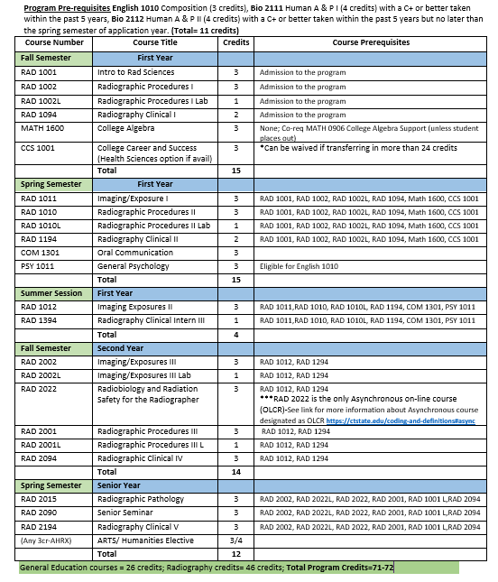

CLINICAL AFFILIATES/FACULTY

- Bristol Hospital
Brewster Rd.
Bristol, CT. 06011
860-585-3000
Instructor: Elise Savino R.T. (R)
- Charlotte Hungerford Hospital
540 Litchfield Street
Torrington, CT. 06790
860-496-6666
Instructor: Lindsey Mathieu, Robert Aviles, R.T. (R)
- Danbury Hospital/ NuVance Health
24 Hospital Avenue
Danbury, CT. 06810
203-739-7000
Instructor: April Lividini, Gabbie Soto R.T. (R)
- New Milford Hospital/NuVance Health
21 Elm Street
New Milford, CT. 06776
860-210-5000
Instructor: Scott Dandeneau R.T. (R)
- St. Mary's Hospital
56 Franklin St.
Waterbury, CT. 06706
Department 203-709-6020
Faculty office 203-709-6290
Instructors: Mirgena Dishnica R.T. (R.) (M.)
Ann Vieira, R.T. (R), (CT), Lisa Reynolds, R.T. (R), Faren Fernandez R.T. (R)
- UCONN Waterbury Hospital Health Center
64 Robbins St.
Waterbury, CT. 06708
Department 203-573-7124
Instructors: Julie Capozzi R.T. (R)
Carolina Craciun R.T. (R), Jessica LaMere (Terrier) R.T. (R)

- Diagnostic Imaging of Southbury
385 Main Street South, Union Square, Bldg. #2
Southbury, CT. 06488
203-267-5800
Manager: Chris Beaulieu NM, R.T. (R)
Instructors: Dayna Dillon R.T. (R)
- Diagnostic Imaging Associates (Naugatuck Valley Radiological Associates)
1579 West Main Street
Waterbury, CT. 06708
203-574-1311
Instructor: Sandra Baez R.T,(R)
- Connecticut Children’s Specialty Care Center – Danbury
105 Newtown Road
Danbury, CT, 06810
Instructor: Janis Flynn, R.T.(R.) 860-837-8120
- Greater Waterbury Imaging Center
64 Robbins Street
Waterbury, CT 06708
203-573-7674
Manager: Susan Castelli, R.T. (R), (MR)
As part of the hospital and considered part of the experiences in clinical rotation.
- Ortho Connecticut of Danbury
2 Riverview Drive
Danbury, CT. 06810
203-702-6605
Instructor: Je’nae Johnson R.T. (R)
- Griffin Hospital
130 Division Street
Derby, CT, 06418
203-735-7421
Instructor: Kimberly Gregg R.T. (R)
- Griffin Hospital OP Center
110 Commerce St.
Shelton, CT. 203-206-7313
Instructor: Danielle Mallozzi R.T. (R)

Required Clinical Competencies
The following minimum clinical competencies are recommended each semester. This number is only a minimum suggestion for students to successfully complete the program. There will be semesters in which more than the minimum must be done. Do not stop performing competencies because you have completed the minimum.

Note: You will need 51 comps (52, effective Class of 2028) in addition to the general patient care requirements. For specific required mandatory vs. elective competency requirements, see the appropriate ARRT clinical competency requirements. Make sure you look at the year according to when you are scheduled to graduate) These documents are listed here in this handbook (See index).

Clinical Internships: Competency by semester suggested
RAD 1094-5-7
RAD 1194- 12-15
RAD 1394- 7-10
RAD 2094 – 12-15
RAD 2194- Remaining competencies

Students who do not complete their competencies or program objectives successfully, will receive an incomplete until they finish and you will not be ARRT board-eligible until completion.

Clinical Requirements: ARRT-Required Competencies
Please note the date of graduation for accuracy of clinical competency requirements. Use the following link to see the documents’ location for reference on the ARRT website
arrt.org/pages/arrt-reference-documents/by-document-type/examination-content-specifications

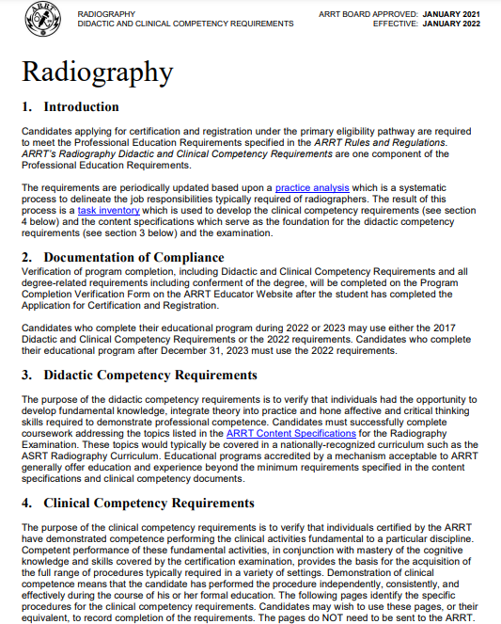
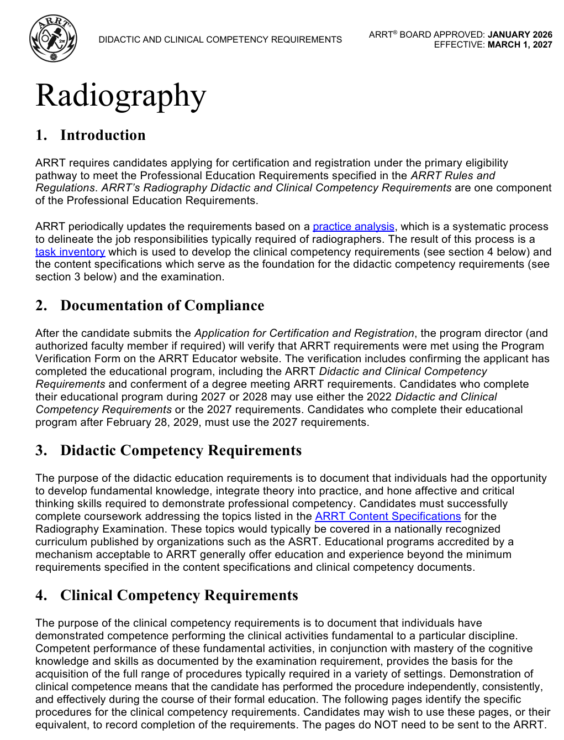
Class of 2027 Requirements Class of 2028+ Requirements
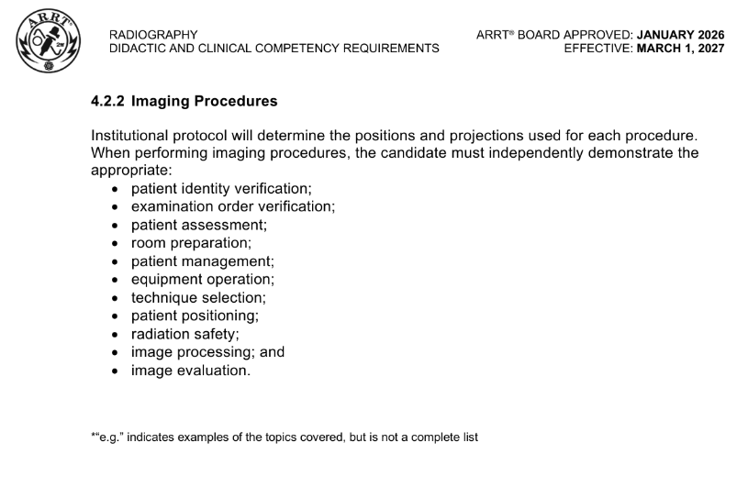
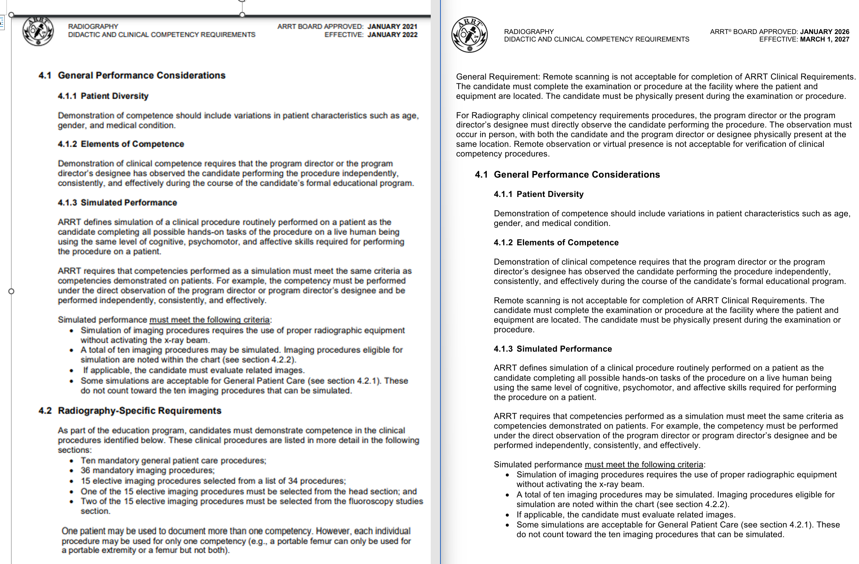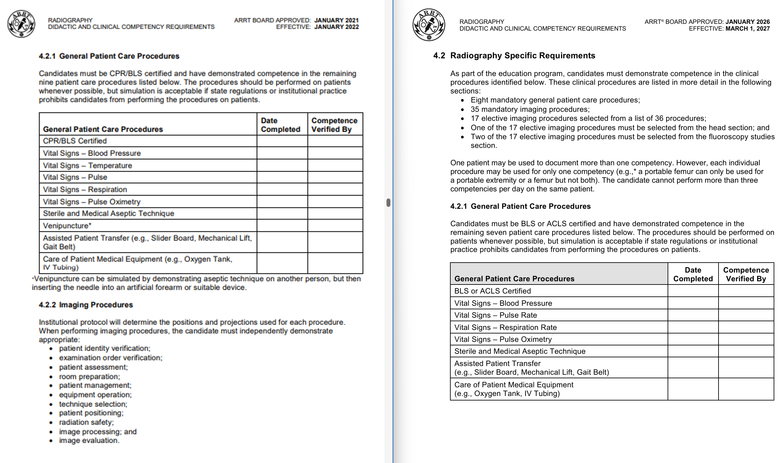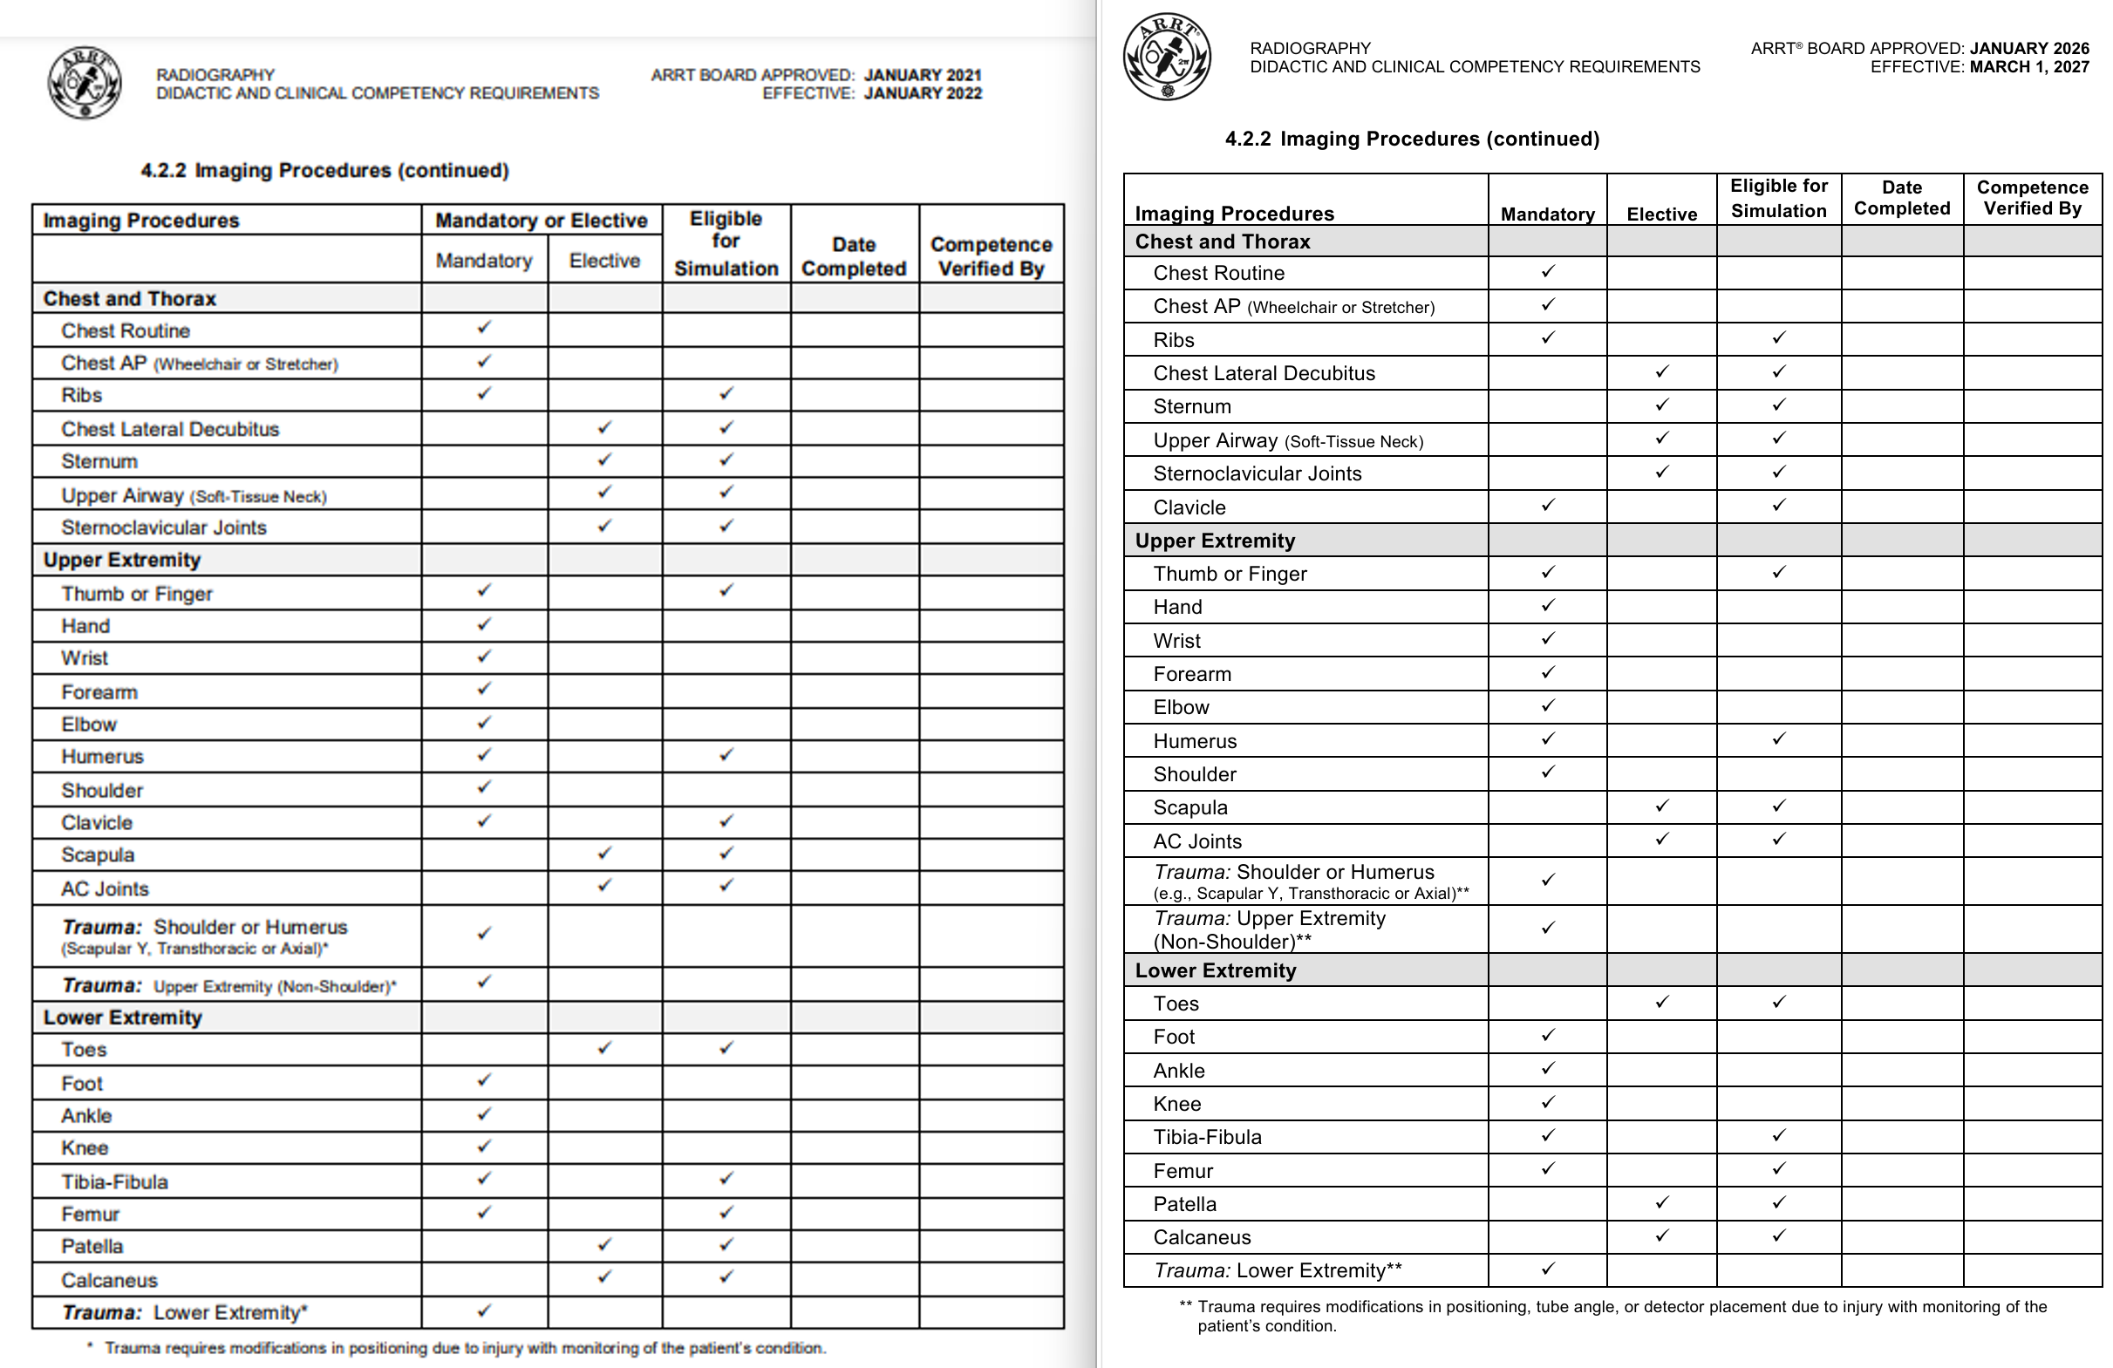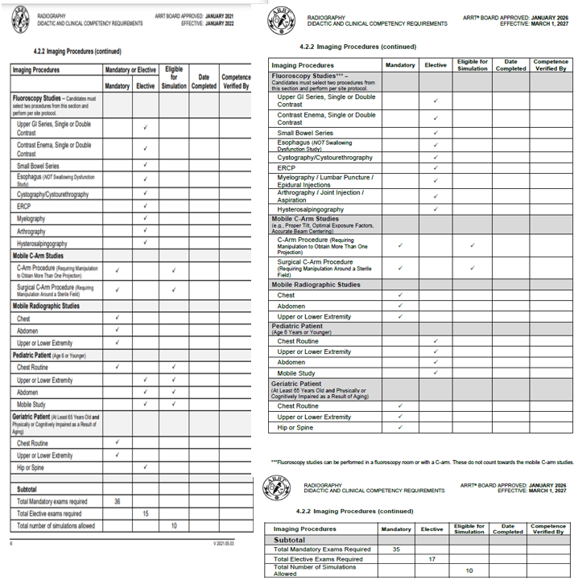

EVALUATION OF THE CLINICAL EDUCATION
Sample evaluation forms used in the Radiography program follow on the next pages. They include Clinical Competency, Professional Behavioral and Clinical Skill Evaluation and
Affiliate Evaluation forms.

The purpose of providing a clinical education is to integrate the knowledge from theory with a "hands-on" clinical experience. This enables faculty to observe students performing the various radiographic procedures and evaluate the skills required, achieving the goal of becoming a competent radiographer.

This is accomplished by rotating students through various clinical assignments in the radiology department, with a correlation of classroom and practical experiences. During the semester, the student's performance will be evaluated. The evaluation to be used is known as a clinical competency and is used to evaluate the student's skill development in performing specific radiographic examinations.

It is not the only means of evaluating the student, but it does contribute to a considerable portion of the student's grade. In total, there are three ways the faculty will evaluate the performance of the student.

Test and Quizzes
Tests and quizzes may be administered throughout the semester at the discretion of the clinical instructors. They are used to test your cognitive domain (thinking, knowledge).

Clinical Competencies
Clinical competencies are designed to evaluate your psychomotor skills. That is, can you transfer your knowledge of performing a radiographic exam to actual practice? The required competencies are listed in this handbook. A student must satisfactorily complete, on the first attempt, at least one of the semester's clinical competencies. If at least one competency is not successfully completed on the first attempt, the student is considered unsafe and is withdrawn from the program.

The competency form used for mandatory, elective and a simulated procedure are located in this handbook. The instrument’s grade key is also presented. Only recognized faculty perform competency evaluations.

Students are required to achieve an 80 or better to satisfactorily complete a competency. A student will be given a second opportunity to perform the competency if he/she fails the first attempt. If, after the second attempt, the student fails the competency, a third attempt may be allowed. To be granted a third attempt, the following must occur:
- The clinical instructor and program director will confer regarding the student's clinical progress. After carefully reviewing the student's progress, the faculty may allow the attempt or withdraw the student for unsatisfactory clinical progress.
- The student is to seek immediate remediation from the program’s retention and remediation specialist (RRS).
- The student will complete a written document on the procedure. The clinical instructor will provide the student with a document outlining the required research to be completed. The clinical instructor will schedule the date on which the document is to be submitted. Upon successful submission of the document, the clinical instructor will determine if a third attempt at the procedure will be allowed.
- If the instructor agrees to allow a third attempt, the student will verbally outline, step-by-step, to the clinical instructor how the procedure is to be performed. The clinical instructor and program director may confer before deciding to allow a third attempt.
- If the student fails a third attempt, they are withdrawn for having unsatisfactory clinical progress.
- The first grade a student receives in performing their competency is the one used to calculate their grade point average.
- Once a student has demonstrated competency in a particular procedure, they may then perform that procedure alone, provided a technologist is in the immediate vicinity under indirect supervision. Students should monitor/maintain their completed competencies. It’s recommended that students complete a list of remaining competencies and provide that list to their instructor each semester. However, this does not mean you will not be tested on that procedure again. If at any time a Clinical Instructor chooses, they may challenge you on any procedure, regardless of whether you have already performed that exam. This challenge is in addition to the required competencies for that semester. The grade of the challenged competency will be computed with quiz grades. Students who fail a challenged competency will be given only one additional opportunity to make up the exam. A student who fails a challenge competency will work under direct supervision until they pass. Failing a challenged competency a third time will result in the student’s withdrawal from the program for having unsatisfactory clinical progress. The challenged competency is not intended to be used on a regular basis, but rather when the student, despite the fact they have passed a competency, may continue to demonstrate poor positioning skills in that area. If a student recognizes that they are lacking in one area or skill, remedial help is available and the student should not hesitate to meet with faculty.
- An unsuccessful first attempt of every clinical competency performed in a semester will result in the withdrawal of the student, and they will not be able to progress in the program.
- Professional Behavioral and Clinical Skill Evaluation: This tool is designed to evaluate the behaviors and skills that the student demonstrates throughout the clinical experience. The instrument is divided into two parts: behavior and skill. The behavior section is used to evaluate the affective domain (attitude, professional ethics, conduct, behavior and values). The skill section evaluates psychomotor skills that may or may not have been assessed during a clinical competency. It will be a summary of the skills demonstrated throughout the semester.
- The evaluation of a student’s behavior and skills will be done twice a semester. This provides the student with an opportunity to improve.
- Affiliate faculty will be evaluating your clinical performance. The evaluation by affiliate faculty will be averaged as part of the quiz grade.

CLINICAL GRADING
Faculty in the radiology program are committed to providing the student with a quality clinical education. It is the faculty’s intent that by providing students with a quality education, they will demonstrate the competence and professionalism needed to become a member of a patient care team.

CRITERIA FOR CLINICAL COMPETENCY EVALUATION

General Evaluation

Evaluation Of Requisition
Student was able to:
- identify the procedure to be performed
- identify the patient's age and name
- pronounce the patient's name
- compare the patient's I.D. bracelet with the X-ray requisition (checks address, date of birth if outpatient)*
- explain the clinical history and input history into the PAC system*

Facilities Readiness
Student was able to:
- provide a clean table
- have an adequate receptor supply
- have emesis basins and emergency medications available
- locate syringes and needles as necessary
- turn machine "on" and prepare for exposure
- turn tube in position necessary for exam
- locate code cart

Patient Care And Safety
Student was able to:
- assist patient to the radiographic room
- assist patient to the radiographic table
- keep patient clothed and/or draped for modesty
- talk with the patient in a concerned, professional manner
- have patient attired properly
- follow proper isolation when appropriate
- perform proper sterile technique when appropriate
- explain the exam to the patient
- communicate the progress of an exam
- demonstrate standard precautions*
- complete patient data entry
- recognize and respond to emergency situations

Digital Fluoroscopy
Student was able to:
- identify the proper contrast media for exam*
- prepare contrast media for the exam
- identify contraindications for contrast media used
- prepare room for the fluoroscopic exam
- monitor the patient for a contrast reaction
- perform proper radiation safety procedures during a fluoroscopic exam
- send images to the picture archive communication system

There is a one-point deduction for each task not performed.
*Critical Task - Grading begins at 80 if the student does not properly identify the patient or establish an appropriate clinical history.

Student Performance
Correct Radiographic Positioning*
The student was able to:
- position patient on table correctly
- use upright Bucky if appropriate, use DR/CR if appropriate
- remove unwanted articles and anatomical parts
- obliqued if necessary
- lateral if necessary
- correct phase of respiration
- superimposition from other body parts
- used proper immobilization

Subtract one point for each skill not performed properly up to a maximum of 3 points.

*Critical Task - Grading will begin at 80 if the student: radiographs the wrong part, performs the wrong procedure or performs the wrong routine.

Correct Central Ray Location
The student was able to:
- demonstrate proper tube angle (1 point)
- demonstrate proper central ray entrance/exit (1 point)
- align body part to center of image receptor (1 point)

Correct Selection of Technical Factors*
The student was able to:
- measure the patient and interpret the technique (1 point)
- set machine according to appropriate technical factors (1 point)*
Excessive technique or underexposure results in an unsuccessful completion of competency (At the discretion of the instructor and based on the technique that should be used).
- modify exam tag in a cassette-less room
- adjust technique according to pathology or other circumstances (ex. SID change, grid vs. non-grid) (1 point)

Correct Equipment Selection and Use
The student was able to:

- properly use equipment (1 point)
  - grid
  - turn table from horizontal to vertical.
  - move the Bucky tray and utilize the locks
  - insert receptor in Bucky tray properly
  - proper use of collimator (automatic or manual)
  - proper use of digital image receptors
- proper image receptor (1 point)
  - correct size and orientation to part
- use proper SID (1 point)
  - check SID
  - compensate to reduce magnification/exposure

Correct Patient Markers
The student was able to:
- use proper markers (including hourly, minute, erect, etc.)
  - marker not used/improper marker used (0 points)*
  - used proper marker and made adjustment for collimation and position of part (3 points)
*Critical task - Grading will begin at 80 for not using or using the wrong marker

Radiation Protection*
The student was able to:
- question females, within childbearing age, concerning the possibility of pregnancy
- document the date of last menstrual period
- input data concerning LMP /pregnancy into PAC system
- protect and shield the patient by the proper use of apron, gloves, shadow shields, etc. Shielding of ALL patients is required. Student shielding during mobiles is required (in accordance with the facility’s policy).

*Critical task - Grading will begin at 80 for not performing critical tasks.

Repeated Exposure*
The following key will be used to deduct points for repeated images:
- < 4 images = 5 points for each repeat
- 4 - 6 images = 3 points for each repeat
- > 6 images = 1 point for each repeat

*Critical Task – Grading will begin at 80 if all images have to be repeated on exams with 3 or less images. Grading will begin at 80 if 50% of the images have to be repeated on exams with 4 or more images.

It is the discretion of the clinical instructor to establish a time limit to perform each radiographic position. The time limit is set by the instructor and is determined by the complexity of the exam, the student's current skill level, pathology and patient condition. Faculty may deduct points for exceeding the time limit.

Criteria for Image Evaluation
The radiograph(s) demonstrate(s):

- Anatomical part(s):
  - part is shown in the correct position and without motion (2 points)
  - marker appears on image (3 points)
- Proper alignment
  - part centered (2 points)
  - tube centered (to table and IR) (1 point)
- Post Processing
  - CR/DR system used properly (1 point)*
    - receptor inserted properly CR
    - receptor prepared for next case CR
    - receptor DR Crosswise/Lengthwise
    - Correct image format (2,3,4 on one)
    - Properly sent to printer if required
- Manipulation of patient and image data correct**
- Sensitivity number (S number) is within range of accepted standards
  - If above or below of accepted standard the image is to be considered as repeated
  - if sensitivity number is at the low or high end of acceptable standards deduct 1 point per image when at high end (lower dose) deduct 2 points per points per image at low end (higher dose)
- Image windows are used correctly/image annotated properly (1 point)
- Image is stored into PAC system and in proper order (1 point)

*Critical Task – grading begins at 80 if the case is deleted and the procedure is repeated
**Critical Task-start at 80 if the student assigns or would have assigned the wrong patient to the images taken

Radiation Protection
- Cone or collimator limits visible (appropriately)
  - four sides present/student attempted to collimate four sides (3 points)
  - three sides present (2 points)
  - two sides present/student only collimate one way (1 point)
  - one or no sides present/ the student did not collimate (0 points)
Note: Collimator limits may not always be visible on the CR image. The instructor is required to observe the student collimating during the procedure. Students who collimate (4 sided) but the cone cut is not obvious will not have a point deducted unless the field size could have been reduced more than the student adjusted. This is at the discretion of the instructor. The instructor will consider the size of the anatomical part / image receptor when determining their rating.
- Evidence of proper patient shielding if applicable
  - Apron or shields protect appropriate parts in the primary beam if applicable.
- Knowledge of Anatomy and Alternate Projections
  - The student identifies anatomy on the radiograph
  - The student identifies alternate projections

Each wrong answer (1 point)
Questions and format are the discretion of the instructor

Program Criteria For Simulated Image Evaluation
Simulated radiograph would demonstrate:
- Anatomical part
  - Skills would show part in proper position (1 point)
  - Proper actions taken to prevent unnecessary motion of part (1 point)
  - Identifies anatomy on teaching radiograph (1 point)
- Proper alignment
  - IR and tube centered (1 point)
  - Part centered (1 point)
  - Patient positioned correctly (1 point)
- Radiographic quality
  - Correct mAs (1 point)
  - kVp adequate according to part (1 point)
  - Compensation of factors correct according to patient's condition (1 point)
- Radiation protection
  - Visibility of cone cuts (2 points)
  - Protection devices adequately shield the patient from the primary beam if applicable (1 point)
Reviewed: 08/20/2020, 07/2023, 8/22/2024, 8/23/2025, 08/14/2026
Revised: 01/15/2022,07/27/2023, 8/22/2024

Clinical Competency Evaluation Form
Student Name: Date:
Instructor:
Radiologic Procedure: Requirement Type: (Mandatory or Elective)
Patient Number:

Evaluation Requisition
The student was able to:
- identify the procedure to be performed
- identify the patient's age and name
- pronounce the patient's name
- compare the patient's I.D. bracelet with the X-ray requisition (check address/DOB if outpatient)*
- explain clinical history*

Facilities Readiness
The student was able to:
- provide a clean table
- have an adequate IR supply
- have emesis basin and emergency medications available
- locate syringes and needles as necessary
- prepare machine for exposures
- locate the code cart
- turn tube in positions necessary for exam

Patient Care and Safety
The student was able to:
- assist patient to radiographic room
- assist patient to radiographic table
- keep patient clothed and/or draped for modesty
- talk with patient in a concerned, professional manner. Modifies communication to be age / cultural appropriate
- have patient attired properly
- follow proper isolation procedure when appropriate
- perform proper sterile technique
- explain exam to patient
- communicate progress of exam to patient
- demonstrate standard precautions*
- complete X-ray requisition including computer entry when appropriate
- recognize and respond to emergency situations

Digital Fluoroscopy
The student was able to:
  - identify the proper contrast media for exam*
  - prepare contrast media correctly for exam
  - identify contraindications for contrast media chosen
  - prepare room for fluoroscopic exam
  - monitor patient for reaction

Performance Evaluation
Positions:
Correct radiographic positioning*
Correct central ray location
Correct selection of technical factors
Correct equipment selection and use
Correct markers and identification*
Radiation protection*
Repeated exposure*

Image Evaluation
Positions:
Anatomical Part
Proper alignment
Post-Processing
Radiation Protection

Failed to perform a critical task:
Max points:
Professional adjustment:

Grade:
*Critical Task - Grading begins at 80 for not performing critical tasks * Inadequate identification
*Inadequate history
*Did not demonstrate standard precautions
*Wrong part
*Wrong procedure, routine
*Wrong markers or no markers
*No LMP or Pregnancy
*If all images have to be repeated on exam with less than 4 images
*50% of the images repeated with exams with 4 or more images
*Unable to identify the proper contrast media for exam
*If the student assigns or would have assigned the wrong patient to the images taken

Created 6/11/06 Reviewed 6/6/08, 3/9/09, 02/20/18, 08/20/2020, 08/20/2021, 7/27/2023, 8/22/2024, 08/23/2025

C-ARM EVALUATION MOBILE FLUOROSCOPIC EXAM FORM
Student________________________ Date_______________
Evaluator_______________________ Procedure_______________________
Facility_________________________

Please check one:
- Manipulation around sterile field
- Manipulation requiring more than one projection
Medical Record Number____________

PERFORMANCE EVALUATION
Rate each area below by placing the point value in the appropriate space.
3 = The student performed the skill without assistance
2 = The student required minor assistance when performing skill.
1 = The student required major assistance when performing the skill.
0 = The student was not able to perform the skill.

The student was able to:

- Prepare equipment for use
- Move equipment into the surgical suite
- Position equipment in room
- Assist in draping the image intensifier
- Maintain sterile technique*
- Observe that the surgical staff is wearing radiation protection apparel
- Wear radiation protective apparel
- Manipulate the C-arm properly and according to anatomy*
- Fluoroscope when required
- Properly store images when required
- Attempt to reduce radiation exposure
- Record fluoro time (if required)
- Dismantle the equipment upon completion of procedure
- Disinfect equipment upon completion of procedure

* Critical task – Grading begins at 80 for contamination or if the technologist has to perform the procedure.

Performance Total __________ / 45 Max. points = ____%

Grading Scale: Minimum of 80% for successful completion of competency.

COMMENTS:

______________________________ ______________________ R.T. (R)
Student Signature Evaluator Signature

The student’s signature indicates that the student has reviewed the evaluation and does not indicate agreement.

Reviewed: 08/20/2020, 07/2023, 8/22/2024, 8/23/2025, 08/14/2026, Revised: 01/15/2022,07/27/2023

PROFESSIONAL BEHAVIOR / CLINICAL SKILL ASSESSMENT

____________________________ ____________
Student Term

________________ ____________
Affiliate Date

The following evaluation is used to assess the student’s professional role and clinical, skills. It is used during RAD 197, 198, 199, 297, 298 and 299. Please read each statement carefully before assigning the student a rating. Evaluate the student on their abilities, length of time in the program and level of expectation. To receive a rating of “4” the student must have consistently demonstrated that behavior/skill.

PROFESSIONAL ROLE / BEHAVIOR EXPECTATION
COMMITMENT TO LEARNING – the ability of the student to report to clinical, prepared for their clinical assignments, and to be up to date with past and current readings/procedures.
- The student is consistently prepared for the clinical assignment. Demonstrates evidence or having read and studied for their rotation. This is consistently evident by the demonstration of procedures assigned during their rotation at their current level of expectation. (4 points)
- The student demonstrated evidence of not being prepared for their clinical assignment on at least 3 occasions. (3 points)
- The student demonstrated evidence of not being prepared for their clinical assignment on at least 5occasions. (1 point)
- The student demonstrated evidence of not being prepared for their clinical assignment on more than 5 occasions and is not responding or demonstrating corrective action recommended by clinical instructor (0 point).

PATIENT RAPORT – the ability of the student to communicate and interact with their patients.
- The student consistently responds to patient requests, explains procedures, demonstrates compassion/concern and respects patient privacy. (4 points)
- The student usually responds to patient requests, explains procedures, demonstrates compassion/concern and respects patient privacy. (3 points)
- The student communicates with the patient only as necessary and occasionally demonstrates compassion/concern for the patient. (2 points)
- The student consistently displays poor tact and communication with patients and does not appropriately address patient, answer questions, nor respond to patient needs or requests. (1 point)

INITIATIVE – the ability of the student to seek work, remain busy, assist others, remain in the department and report for each assignment prepared.
- The student consistently remains busy and is a self-starter that actively seeks work, volunteers to help other and desires to learn. (4 points)
- The student often remains busy seeking work, assisting others and remaining available. (3 points)
- The student accepts work as assigned and on occasion seeks work or assist others (2 points)
- The student rarely or never seeks work and participates only if requested. The student often observes rather than participates. (1 points)

ATTENDANCE / PUNCTUALITY – the attendance and promptness of the student throughout the semester.
- The student is consistently present and on time. (4 points)
- The student had one absence, one tardy or one occasion when conference was not attended. (3 points)
- The student had 2 occurrences or combinations of being absent, late or not attending conferences. (2 points)
- The student had 3 occurrences or combinations of being absent, late or not attending conference. (1 points)
- The student had 4 occurrences or combinations of being absent, late or not attending conference. (0 point)

PERSONAL APPEARANCE
- The student presents a professional appearance and consistently dresses according to program policy. (4 points)
- The student’s appearance is usually professional and uniform is usually clean and neat. (3 points)
- The student’s appearance is satisfactory but did not dress according to policy on at least one occasion. (2 points)
- The student’s appearance is unsatisfactory– uniform is consistently untidy or did not dress according to policy on more than two occasions. (1 point)

JUDGEMENT – the ability of the student to practice according to theoretical knowledge, reason and use discretion when carrying out assignments.
- The student consistently makes appropriate decisions and practices radiologic technology based upon theoretical knowledge. (4 points)
- The student usually makes decision and practices radiologic technology based upon theoretical knowledge. (3 points)
- The student demonstrates some ability to reason and make decisions according to principles and practices. (2 point)
- The student uses poor or illogical decision-making skills demonstrated. (1 points)

COOPERATION AND INTERPERSONAL SKILLS – the ability to communicate, listen to suggestions for improvement and promote team work with instructors, staff and fellow classmates.
- The student consistently works well with others and promotes team work. The student demonstrates respect for authority. The student listens and follows instructions and recommendations. (4 points)
- The student usually works well with others, listens to suggestions, modifies behavior and get along well with others. (3 points)
- The student at times works well with others, listens to suggestions, modifies behavior and gets along well with others. (2 points)
- The student is often short tempered, lacks diplomacy and may be curt or rude with others. (1 point)
- The student consistently demonstrates poor working relationship with others. (0 points)

ADAPTATION / PERFORMANCE UNDER PRESSURE – the ability to adapt to new experiences as well as remain calm during critical or busy situations.
- The student readily adapts to new experiences or remains calm in the event of an emergency. (4 points)
- The student usually adapts to and usually can handle busy or critical situations. (3 points)
- The student demonstrated some difficulty at times in adapting or handling a busy situation. (2 points)
- The student demonstrated frustration often and on occasion loses temper. (1 point)
- The student cannot adapt or handle a critical situation. (0 points)

Clinical Skills Assessment
PATIENT CARE / ASSESSMENT– the ability of the student to lift/move patients, recognize emergencies, perform proper history/assessment prior to beginning procedure, maneuver equipment (IV’s, tubes, wheelchairs), demonstrate universal standards, perform sterile technique and prepare contrast media at current level of expectation.
- The student consistently demonstrates proper patient care techniques, patient equipment manipulation and practices universal standards at all times. (4 points)
- The student usually demonstrates proper patient care techniques, patient equipment manipulation and practices universal standards. (3 points)
- The student is inconsistent in demonstrating patient care techniques (2 points)
- The student’s patient care techniques are lacking and the student is marginal in terms of patient safety. (1 point)
- The student is unsafe and never demonstrates appropriate patient care techniques. (0 points)

QUALITY OF WORK – the ability of the student to complete tasks with accuracy and thoroughness, as well as neatly. The number of times the student repeats is also evaluated.
- The student consistently meets the highest standards for accuracy, thoroughness and neatness. (4 points)
- The student’s work is satisfactorily completed with accuracy, thoroughness, neatness and the student recognizes errors and takes the appropriate corrective action. Radiographic repeats would be minimal. (3 points)
- The student makes errors during experiences and at times and the student does not always recognize the mistake. Some repeats would occur. (2 points).
- The student frequently makes errors and demonstrates some difficulty in recognizing the error or taking corrective action. Numerous repeats would occur. (1 point)
- Work quality is poor and there are repeated mistakes without recognition of the error or performing corrective action. Numerous repeats would occur. (0 points).

QUANTITY OF WORK- the volume of work accomplished by the student.
- The student’s work productivity is high and the student consistently does more than expected in a timely manner. (4 points)
- The student’s satisfactorily completes work in time expected. (3 points)
- The student’s work is completed but often exceeds the amount of time expected to complete the assignment. (2 points)
- The student’s tasks are completed slowly or at times not completed at all. (1 point)

PERFORMANCE OF RADIOGRAPHIC PROCEDURES – the ability of the student to perform
procedures, assess the requisition, apply the affiliate routine, process the radiograph and obtain radiologist interpretation when required.
- The student demonstrates consistency in applying knowledge and performing radiologic procedures. (4 points)
- The student demonstrates satisfactory knowledge of the concepts to produce radiographs. (3 points)
- The student demonstrates adequate knowledge of the concepts to produce radiographs. (2 points)
- The student consistently cannot produce quality radiographs. (1 point)

ORGANIZATION OF WORK- the ability of the student to perform tasks in an orderly fashion and in a manner that does not disrupt affiliate work flow and accommodates the patient.
- The student consistently organizes their work without assistance and in and in a manner that does not disrupt departmental activity. The work is performed in a manner that accommodates the patient. (4 points)
- The student satisfactorily organizes their work in a manner that does not disrupt departmental activity. The work is performed in a manner that accommodates the patient. (3 points)
- The student has difficulty organizing their work and at times disrupts departmental activity. The work often does not accommodate the patient. (2 points)
- The student lacks organization. (1 point)

RADIATION PROTECTION - the ability of the student to demonstrate proper radiation protection to self and patient. Shielding is performed in accordance with the facility’s policy. Female patients within childbearing age are questioned about the possibility of pregnancy and the date of the LMP is properly documented.
- Radiation protection procedures and possibility of pregnancy is performed at all times. (4 points)
- Satisfactorily performs radiation protection and pregnancy screening. (3 points).
- Usually applies appropriate protection techniques and pregnancy screening. (2 points)
- The student often does not protect patient, self and perform pregnancy screening. (1 point)
- The student is unsafe in performing radiation protection procedures and pregnancy screening. (0 points)

EQUIPMENT MANIPULATION- the ability of the student to properly manipulate the Bucky, table locks, grids, mobile, fluoroscopic units, digital units, control panels and adjust techniques as needed.
- The student consistently demonstrates proficiency in using the equipment and adjusting techniques when required. (4 points)
- The student satisfactorily demonstrates proficiency in using the equipment and adjusting techniques when required. (3 points)
- The student at times has difficulty utilizing equipment and adjusting techniques. (2 points)
- The student is unsatisfactory when manipulating equipment or compensating techniques. (1 point)

Comments / Suggestion for corrective action:

Points earned / 56 maximum possible points = ___________

The signature of the student does not indicate agreement with the evaluation. The signature indicates the student has seen the evaluation. The student has the right to write comments on the back of the evaluation.

________________________________
Student signature
________________________________
Instructor signature
_______________________________
Final Average Grade

Revised: 3/29/00,5/23/01,06/17/02, 7/2023, 08/22/2024, 08/22, 02/25
Reviewed: 3/26/13,02/20/18, 08/20/2021, 07/27/2023, 08/22/2024, 08/2025, 08/2026

Naugatuck Valley Radiography Program Clinical Affiliate Evaluation

________________________________ _____________
STUDENT'S NAME DATE

________________________________
CLINICAL INSTRUCTOR AFFILIATE

This evaluation is used to assess the student's performance during their rotation at affiliates other than the hospital.

PERFORMANCE: The student performs radiographic examinations with direct or indirect supervision of the clinical instructor
Listed are the areas to evaluate the student on his/her performance at your agency. Read and consider each objective before making your decision, then circle the appropriate rating.
REMEMBER TO BE GIVEN A RATING OF 4 ON THE SCALE THE STUDENT MUST DEMONSTRATE THIS BEHAVIOR 100% OF THE TIME.

RATING SCALE
4 = Competent: The student consistently performs in an effective manner.
3 = Progress acceptable : The student often performs effectively and efficiently.
2 = Needs Improvement: The student does not perform task a majority of the time.
1 = Progress unacceptable: The student does not demonstrate the task and is consistently ineffective and inefficient.

Please add your rating 1-4 after each item.
- Performs radiographic exams according to affiliate procedure manual
- Follows suggestions and instruction
- Performs associated duties
- Adapts knowledge to affiliate procedures
- Organizes work and completes tasks
- Cooperates with staff and instructors

PROFESSIONAL ROLE: Student displays professional behavior which includes legal requirements and patient care responsibilities.
- Communicates and interacts with patients and families in a concerned, professional manner
- Practices universal precautions and follows regulated waste policy
- Dresses according to program policy
- Questions female patients concerning the possibility of pregnancy and documents last menstrual period
- Labels radiographs accurately including patient name, date and side marker
- Maintains patient confidentiality
- Reports to affiliate on time
- Checks patient ID, medical history and documents requisition

EQUIPMENT: Student uses radiographic equipment and devices according to affiliate policy.
- Consistently shields all patients using aprons, gonadal shields and breast shielding (in accordance with the facility’s policy)
- Processes radiographs according to affiliate policy
- During fluoroscopy uses proper radiation protection for self by wearing aprons, thyroid shield, (if available) and collar badge
- Stocks work area with adequate levels of supplies
- Operates radiographic equipment with proper collimation,
- SID, image-tube alignment and technical factors
- Uses image receptors and grids appropriately for radiographic procedures
- Operates computed radiography system

GRADING: This evaluation will be completed at the end of the student's rotation in a clinical affiliate other than the hospitals. The affiliate grade is averaged with the clinical quiz grades.

TOTAL POINTS: ____________ / 80 (84 if affiliate has CR) MAX. POINTS = ________%

COMMENTS:

_____________________________
Student Signature

______________________________R.T. (R)
Instructor's Signature

Revised: 1/24/96, 5/23/01, 07/23
Reviewed: 3/26/13, 2/10/17, 08/20/2020, 08/20/2021, 07/27/2023, 08/22/2024, 8/23/2025

NAUGATUCK VALLEY RADIOGRAPHY PROGRAM INSTRUCTOR’S KEY - CLINICAL AFFILIATE EVALUATION

PERFORMANCE: The student performs radiographic examinations with direct or indirect supervision of the clinical instructor.
1. Performs radiographic exams according to affiliate procedure manual.
- 4 = Performs procedures according to policy and requisition 100% of the time.
- 3 = Performs procedures according to routine most of the time. Occasionally positions or begins the wrong routine.
- 2 = Rarely performs the correct routine and on at least one occasion attempted to radiograph the wrong part or patient (Ex left shoulder when request was for right).
- 1 = Cannot perform the correct routine at all. Demonstrates constant confusion with routines and positions.
NOTE: The above is based on the current level of knowledge the student possesses. The student should not be evaluated on positions/procedures they have not been taught.

2. Follows suggestions and instruction.
- 4 = Consistently listens to and follows instructions. Readily accepts constructive criticism. Is not argumentative and values assistance from staff and the instructor.
- 3 = Usually listens to and follows instructions. Often accepts constructive criticism. On two occasions became argumentative or provided an excuse rather than accept responsibility.
- 2 = Did not follow instructions on more than two occasions. Does not accept constructive criticism easily. When corrected often replies with an excuse instead of admitting to his/her mistake.
- 1= Never listens or follows instructions. Becomes argumentative on any suggestions. Consistently provides an excuse for their actions. Never accepts responsibility for their judgment.

3. Performs associated duties.
- 4 = Consistently willing to help with such tasks as: cleaning equipment, processing radiographs, assisting patients in changing, assisting office staff and physicians/physicians’ assistants (other tasks may be evaluated at the discretion of the instructor).
- 3 = Usually performs associated tasks but on at least two occasions did not. (see above for tasks)
- 2 = On more than two occasions did not perform associated tasks (see tasks above)
- 1 = Never performs an associated task.

4. Adapts knowledge to affiliate procedures.
- 4 = Easily adapts to affiliate and applies current level of knowledge to the procedures/routines to the assigned affiliate.
- 3 = Readily adapted to affiliate. On two occasions demonstrated difficulty in applying current level of knowledge to affiliate procedures/routines.
- 2 = Some difficulty in adapting to affiliate. On more than two occasions demonstrated difficulty in applying current level of knowledge to affiliate procedures/routines.
- 1 = Did not adapt at all. Could not apply current knowledge to practice.
5. Organizes work and completes tasks.
- 4 = All tasks are completed thoroughly. The faculty/staff never have to remind the student to complete task began but not finished. Work is organized in a fashion that will expedite the completion of a procedure in a timely manner. Organization of work is in the best interest of the patient. The student handles pressure in busy situations.
- 3 = On at least two occasions the student did not complete a task. (This is two occasions and involves the same task, not two different tasks) Work is usually organized to complete tasks and procedures in a timely manner. The student can handle pressure in most situations.
- 2 = Faculty/staff often remind student to complete tasks. Student does not demonstrate good organizational skills that will facilitate the completion of the tasks. In busy situations the student gets frustrated.
- 1 = Faculty/staff consistently must remind student to complete tasks. The student does demonstrate good organizational work. The work does not expedite the completion of a task or procedure in a timely fashion. The faculty often have to complete the task or take over the procedure from the student. In busy situations the student gets frustrated and easily loses temper.

NOTE: If workload becomes heavy and the instructor must complete a procedure, the student should not be penalized unless the back log is a direct result of the student's inability to complete tasks or organize their work.

6. Cooperates with staff and instructors.
- 4 = Consistently polite and willing to assist in any way possible. The student participates as a "team player." Uses tact, diplomacy when dealing with affiliate employees.
- 3 = On one occasion the student was rude or curt.
- 2 = On two occasion the student was rude or curt.
- 1 = On more than two occasions the student was rude or curt towards faculty/staff.

II. PROFESSIONAL ROLE: Student displays professional behavior which includes legal requirements and patient care responsibilities.
1. Communicates and interacts with patients and families in a concerned professional manner.
- 4 = The student easily communicates and interacts with patients and families. Language is appropriate. The students uses and modifies terms a level the patient/family can understand. The student is friendly and cheerful.
- 3 = On at least two occasions the student did not appropriately communicate with patients/family. The student did not modify their communication/instruction. On at least two occasions the student was not pleasant or cheerful when interacting with patient/family.
- 2 = The student's communication and interaction needs improvement. Demonstrates some difficulty when communicating with the patient/family. Has difficulty in answering questions and modifying their communication.
- 1 = Avoids talking with patient/family. Appears shy/withdrawn. Has difficulty in starting conversation. Is not cheerful or pleasant.

NOTE: When evaluating these criteria, the instructor needs to consider at what point the student is in the program. For example, a first year first month student will demonstrate some difficulty as compared to a second year first semester student. Terms of endearment when addressing patients are not acceptable.

2. Practices standard precautions and follows regulated waste policy.
- 4 = Consistently practices universal precautions. Disposes waste appropriately. The faculty and staff never have to remind the students to wear gloves, mask etc.
- 3 = On one occasion the student did not follow precautions or dispose of waste properly.
- 2 = On two occasions the student did not follow universal precautions or properly dispose of waste.
- 1 = On more than two occasions the student did not follow universal precautions or properly dispose waste.

3. Dresses according to program policy.
Policy requires a white lab coat (worn at all times), white shoes/sneakers (no color on sneakers), white pants/skirt and colored top, (Blue or Sangria). The student is to have a watch with a second hand. Long hair is to be tied back. Only stud earrings. No jewelry other than a wedding band. No nail polish. The uniform should be neat and clean.
- 4 = Dressed according to above policy 100% of the time.
- 3 = On one occasion the student did not dress according to policy.
- 2 = On two occasions the student did not dress according to policy.
- 1 = On more than two occasions the student did not dress according to policy.

4. Question female patients concerning the possibility of pregnancy and last menstrual period.
- 4 = Questions female patients concerning the possibility of pregnancy 100% of the time. Documents LMP 100% of the time.
- 3 = On one occasion did not question patient concerning the possibility of pregnancy On one occasion did not document LMP.
- 2 = On two occasions did not question patient concerning the possibility of pregnancy. On two occasions did not document LMP.
- 1 = On more than two occasions did not question female patients concerning the
possibility of pregnancy. On more than two occasions did not document LMP.

5. Labels radiographs accurately including patient name, date and side marker.

- 4 = Properly labeled radiographs and used side markers 100% of the time.
- 3 = On one occasion did not properly label images or use side marker.
- 2 = On two occasions did not properly label image or use side marker.
- 1 = On more than two occasions did not properly label image or use side marker.

6. Maintains patient confidentiality.
- 4 = Never discusses confidential information concerning patients or the business of other affiliates.
- 3 = On one occasion the student discussed patient information or the business of other affiliates.
- 2 = On two occasions the student discussed patient information or the business of other affiliates.
- 1 = On more than two occasions the student discussed patient information or the business of other affiliates.

7. Reports to the affiliate on time.
- 4 = Reported to affiliate on time and prepared 100% of the time.
- 3 = On one occasion the students were late or not prepared.
- 2 = On two occasions the students were late or not prepared.
- 1 = On more than two occasions the students were late or not prepared.

8. Checks patient ID, medical history and documents requisition.
- 4 = Checks patient ID, medical history and documents (as necessary) requisition 100% of the time.
- 3 = On one occasion, the student did not check ID, medical history or document requisition.
- 2 = On two occasions, the student did not check ID, medical history or document requisition.
- 1 = On more than two occasions, the student did not check ID, medical history or document requisition.

III. EQUIPMENT: Student uses radiographic equipment and devices according to affiliate policy.
1. Consistently shields all patients using aprons, gonadal shields and breast shielding.
- 4 = Shields patients in accordance with Facility’s policy.
- 3 = On one occasion did not shield patient.
- 2 = On two occasions did not shield patient.
- 1 = On more than two occasions did not shield patient.

2. Processes radiographs according to affiliate policy.
- 4 = Processes radiographs consistently and with accuracy.
- 3 = On two occasions did not properly process radiograph.
- 2 = On more than two occasion did not properly process radiographs.
- 1 = Never processed radiographs.

3. During fluoroscopy uses proper radiation protection for self by wearing aprons, thyroid shield (if available) and collar badge.
- 4 = Wears protective apparel properly and places collar badge outside lead apron 100% of the time.
- 3 = On one occasion did not wear apparel properly or place the collar badge outside the lead apron.
- 2 = On two occasions did not wear apparel properly or did not place the collar badge outside the apron.
- 1 = On more than two occasion did not wear proper apparel or did not place the collar badge outside the apron.

4. Stocks work area with adequate levels of supplies.
- 4 = The work area is always stocked. The faculty/staff never have to remind the student to replace supplies.
- 3 = On two occasions the student was reminded to maintain supplies.
- 2 = On more than two occasions the student had to be instructed to replace supplies.
- 1 = The student never replaces supplies is constantly being reminded by faculty/staff.

5. Operates radiographic equipment with proper collimation, SID, image-tube alignment, and technical factors.
- 4 = Equipment is used properly. The student demonstrates the correct relationship of technical factors and image quality.
- 3 = On two occasions the student did not properly use equipment, align tube with image receptor, center tube to buck, set technique, etc.
- 2 = On more than two occasions the student did not properly use equipment, align tube with receptor, center tube to buck, set technique, etc.
- 1 = The student never properly used equipment, align tube with image, center tube to buck, set technique, etc.

6. Uses image receptors and grids appropriately for radiographic procedures.
- 4 = Receptors/grids consistently used properly.
- 3 = On two occasions the student did not properly use receptors or grids.
- 2 = On more than two occasions the student did not properly use receptors/grids.
- 1 = The student never properly used receptors/grids.

7. Operates Computed Radiography system.
- 4 = Operates CR system satisfactorily. Images or patient data were not lost.
- 3 = On two occasions lost images or had difficulty with CR system.
- 2 = On three occasions lost images or had difficulty with CR system.
- 1 = On four occasions lost images or had difficulty with CR system

Reviewed: 2/20/18, 8/20/2020, 08/20/2021, 07/2023, 08/22/2024, 8/23/2025, 08/14/2026
Revised: 2/20/18, 07/27/2023

Appendix A. Student Health Requirements

Policy
Physical exams are required within three months of admission into the radiography program. Exam documents are to be submitted and completed before a student can attend clinical experiences. At the cost to the student Castle Branch Inc. which provides colleges, universities and other education institutions nationwide with background screening and compliance management solutions, including background checks, drug testing, immunization and record tracking and document management provides the management and compliance of all radiologic technology students.

Procedure
- Health requirement forms are mailed by the program director in the information packet in May. They may also be found in the Castle Branch Radiologic Technology portal (see instructions following page).
- Students use the physician of their choice. The form or forms are uploaded to the Castle Branch portal.
- The exam requires immunization history, MMR, TB test, Varicella, Tdap and Hepatitis B. The Hepatitis B vaccine also requires a titer or if they did not convert a waiver. During the second year, students are required to receive an updated TB test.
- The Radiography program director or clinical coordinator will confirm in writing to each hospital clinical affiliate the names of the students they are assigned and the student is compliant with health requirements. The letter is sent prior to the students beginning their clinical rotations. The hospitals must receive the letter before the semester starts. The letter begins the process of giving the students ID badges.
- Students seeking accommodations are required to submit medical documentation to the Disability Services office. If the accommodation is granted faculty that is assigned the student will be informed of the student’s accommodation.
- Connecticut hospitals require all students and faculty receive the flu vaccine. Some clinical affiliates will inoculate faculty and students for free. Other affiliates will not. Students or faculty that decline the vaccine for health or religious reasons will be required to wear a mask at all times when in clinical during the flu season.

Medical Requirements Recording for Naugatuck Valley Radiography Students
- Go to https://portal.castlebranch.com/nw41
- To pick package selection, click “Please Select” and go down to NW44bgim: I am an incoming freshman and need to order my Background Check and Compliance Tracker
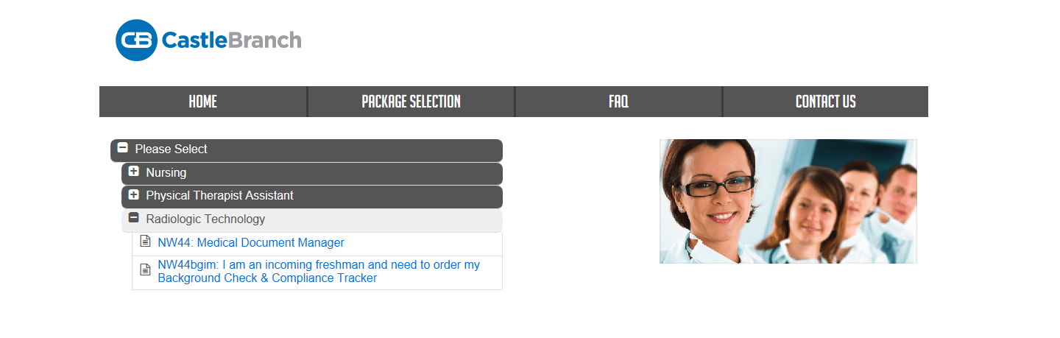
- Create an account
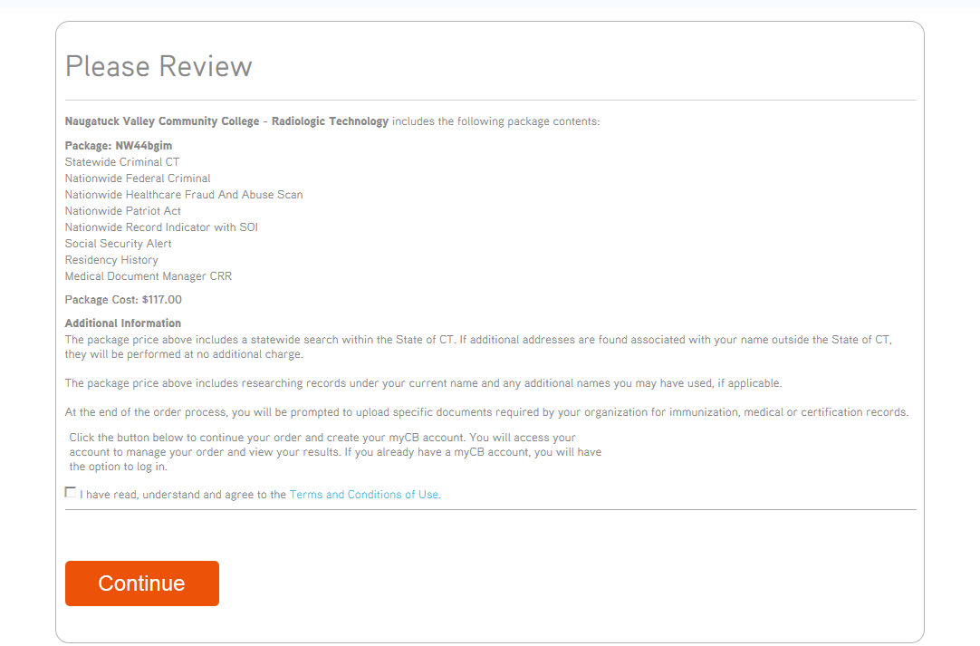

- Go to “To-Do Lists” section and scan in your documents
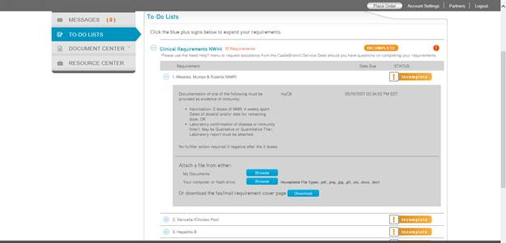
Reviewed: 2/20/18, 8/20/2020, 08/20/2021, 07/2023, 08/22/2024, 8/23/2025
Revised: 2/20/18, 07/27/2023

Appendix B. Program Technical Standards
Candidates for admission to the Radiography program at N.V. should consider the physical demands required of a radiographer. Reasonable accommodations may be made to assist the student in meeting the program's objectives. A request for an accommodation is evaluated on a case-by-case basis and after the candidate/student has disclosed their condition. The evaluation for accommodations includes supporting medical documentation and may require the simulation of a required skill.

During their clinical education, the radiologic technology student will:
- Be on their feet 100% of the time during an eight-hour clinical day
- Lift and move patients from stretchers and wheelchairs to the radiographic table
- Lift and position non-ambulatory or unresponsive patients
- Bend over to pick up equipment, including but not restricted to lifting foot boards to be attached to the table or image receptors to be carried to the CR Reader
- Drive and steer a mobile radiographic machine. The machine is motorized. However, when driving the machine, the student will be expected to make sudden stops and turns to avoid beds, equipment and pedestrians.
- Manipulate the radiographic tube crane and fluoro tower into various positions when performing radiographic procedures. This often requires reaching above one’s head with 2 hands to move the tube.
- Respond quickly in an emergency situation. This could include, but not restricted to running while carrying or pushing equipment.
- Carry image receptors back and forth between the radiographic room and CR Reader or other departments within the clinical affiliate.
- Hear effectively, audible sounds of equipment such as termination of the radiographic exposure, tube rotor, blood pressure, overhead voice page and hospital pagers.
- Effectively recognize conditions or settings on equipment such as radiographic technique, termination of the radiographic exposure, angle meters, computer screens and blood pressure gauges.
- Communicate effectively when providing patients with instructions or questioning the patient to obtain a medical history, consent for procedures, documentation of pregnancy or instructions during a procedure
- Effectively recognize and possess motor skills to manipulate the digital imaging and Picture Archiving Communication System (PAC) to produce and store images properly.
- Perform fluoroscopic procedures while wearing a lead apron. The apron is heavy and may need to be worn two or three hours at a time.
- Wear a surgical mask, rubber gloves, isolation gowns or other protective apparel. Be able to communicate with patients or staff while wearing protective apparel.

Reviewed: 2/21/2018, 8/24/2019, 08/18/20, 08/20/2021, 07/2023, 08/22/2024, 8/23/2025, 08/14/2026
Revised: 2/21/2018, 07/27/2023

APPENDIX C. PROCEDURE FOR REPORTING INJURIES
***Read the procedure and fill out the form below in accordance with this procedure.

Effective Date: February 28, 2018

Purpose
The purpose of this procedure is to have a singular system for reporting student, employee, and visitor injuries that occur on campus and during college-sponsored activities.

Scope
This procedure applies to all employees, students, and visitors who, as a result of an accident or incident on campus and/or during CT State-sponsored events, are injured or exposed to hazardous substances. This procedure supersedes all other previous procedures and guidance relating to this topic.

Procedure
﻿﻿Medical emergencies should be reported to the Public Safety Department. The responding officer will summon emergency response if deemed necessary or if requested by the injured party.
﻿﻿An incident resulting in an injury or a chemical exposure to any employee, student, or visitor that occurs on campus or while participating in CT State-sponsored activities is reported by completing the Incident Report Form (see attached) within three (3) days of the incident. Please note the following:
- ﻿﻿This form does NOT replace Form WC-207, First Report of Injury. When an employee is injured, the First Report of Injury Form must still be submitted to the Human Resources Department and all Worker's Compensation procedures must be followed.
- ﻿﻿A report by the Public Safety Department does NOT fulfill the requirement of completing and submitting the Incident Report Form.
- ﻿﻿Students injured while participating in college activities may be covered by the college's accident insurance policy. It is the student's responsibility to follow the procedures listed in the student handbook to receive reimbursement for costs incurred.
- ﻿﻿When the incident involves a visitor or student, the responsible staff or faculty member ensures that the form is completed and submitted.
- ﻿﻿The Incident Report Form may be obtained by contacting the offices of the Dean of Student Services at 203-575-8012 or the Dean of Administration at 203-575-8089.
- ﻿﻿The completed form is sent to the Dean of Administration's office, K706. A copy of the form should be given to the party involved in the incident. The DOA's office will then send forms to either the Dean of Student Services (student injury) or Human Resources (employee injury). All others will be kept on file in the DOA's office (i.e. visitors).
- The campus Health and Safety Committee will review reports and, if warranted, its recommendations for addressing safety concerns will be reported in meeting minutes and to the appropriate division or department. In the event that immediate action is required to ameliorate a hazard, the committee will report its findings directly to the dean of administration and the public safety department.

Questions regarding this procedure should be directed to the deans, either Sarah Gager or Dana Elm.

Incident Report Form-Injury or Chemical Exposure
Directions: This form is completed when an employee, student, or visitor is injured or exposed to a chemical while on campus or during college-sponsored events. When the incident involves a student or visitor, the faculty member or college sponsor of the event is responsible for completing the form. Submit the completed form to the Office of the Dean of Administration (K706) within three days of the incident. Alternatively, an electronic copy can be sent to dana.elm@ctstate.edu.

PERSONAL INFORMATION
Name: (Last, First, Middle): Date of Birth:
Address: Phone:

$□$ CT State Naugatuck Valley Employee $□$ CT State Naugatuck Valley Student
$□$ CT State Naugatuck Valley Visitor Student ID#:

INCIDENT INFORMATION
Date of Incident: Time of Incident: Location:
Nature of Incident:

Was CT State Naugatuck Valley Public Safety Department or Security notified? $□$ Yes $□$ No
For employees, was the First Report of Injury Form (WC-207) completed? $□$ Yes $□$ No
Witness name(s):
Details of incident (include description and extent of injury and how the injury/exposure occurred):
Describe initial action at time of injury (i.e., first aid):
Was further medical treatment recommended? $□$ Yes $□$ No
If yes, by whom?
Was the patient injured and transported for further medical treatment? $□$ Yes $□$ No
Was further treatment received? $□$ Yes $□$ No
If yes, where and when?
What recommendations do you have for preventing other accidents of this type?

My signature affirms that I have reviewed this form and the information is true and correct to the best of my knowledge.

Preparer's Name and Title: Division/Department:
Preparer's Signature: Date:
Signature of Injured Party: Date:

Important Notes:
Employees - This form does not replace Form WC-207, First Report of Injury, which must be submitted to Human Resources.
Students - Students may be covered by accident insurance if injured during college activities. It is the student's responsibility to follow procedures provided in the student handbook in order to be reimbursed for medical costs incurred.
Revised: Jan 2018
Reviewed 07/2019, 08/ 2020, 08/2021, 07/27/2023, 8/23/2025, 08/14/2026

Appendix D. PROGRAM GRADING SYSTEM (TRAJECSYS/Typhon)
The Naugatuck Valley radiography program utilizes an electronic grade system called Trajecsys. Students will need to go on to the Trajecsys webpage to register. You may register up to 45 days prior to the first day of classes. We suggest you do so, so that you can familiarize yourself with the system. trajecsys.com/programs/registration.aspx

Any announcements made to the grading system will be listed for you under announcements. We request that students check announcements once a day. During your first weeks of training on campus, the instructor will go over the grading system and what you will be responsible for completing and how to access evaluations, grades, log books and other useful items.

Trajecsys is to be phased out with the class of 2027. Typhon will be the CRM to fulfill the responsibilities of Trajecsys starting with the class of 2028. typhongroup.com

Appendix E: DECLARATION OF PREGNANCY
To: Mark Martone, M.S., R.T. (R)

In accordance with the NRC’s regulations at 10 CFR 20.1208, “Dose to an Embryo/Fetus, “I am declaring that I am pregnant. I believe I became pregnant in ___________________________ (only month and year need to be provided).

I understand the radiation dose to my embryo/fetus during my entire pregnancy will not be allowed to exceed 0.5 rem (5 millisievert) (unless that dose has already been exceeded between the time of conception and submitting this letter). I also understand that meeting the lower dose limit may require a change in job or job responsibilities during my pregnancy.

_____________________________________________________
Your Signature

______________________________________________________
Your Name Printed

________________________
Date

Appendix F: PREGNANCY GUIDELINES
- Never stand in the primary beam.
- Never hold a patient.
- Faculty recommend (but it is voluntary), that you inform the technologist you are working with that you are pregnant.
- DO NOT let familiarity result in a false sense of security.
- Dosimeter badges are to be worn at all times. The waist badge is to be placed at waist level and worn UNDER the apron. The collar badge is to be worn OUTSIDE the lead apron.
- The recommended fetal dose during pregnancy annual dose to the occupational worker is 50 mSv (5 rems or 5,000 millirems) per year. The maximum allowed dose to the fetus for the entire gestational period is 1/10 that of the occupational exposure which is 5 mSv (.5 rem or 500 millirems).
- With your consent, faculty will arrange assignments so the suites where exposure is possible will occur towards the end of the semester.
- Remember the cardinal principles of radiation protection: TIME DISTANCE and SHIELDING
- TIME – The length of time you are exposed to the radiation should be kept to a minimum
- DISTANCE-Maintain a long distance between you and radiation source.
- SHIELDING- Insert shielding between you and the source.
- Use caution when entering a radiographic room. Enter the room from the control panel area. DO NOT OPEN THE DOOR DIRECTLY INTO THE SUITE. When in the surgical suite, open door slowly and wait until beam is off before entering.
- Mobile units are equipped with a 6’ exposure cord. Stretch the cord to its maximum length and move in the opposite direction of the tube to make an exposure. Program policy requires the student wear an apron when making a mobile exposure even if 6’ from the unit.
- In fluoroscopy wear lead apron and use mobile lead shields (doors). In the remote rooms the mobile lead shield is important due to the location of the tube. Inform the radiologist performing the procedure that you are pregnant. Use other personnel in the room as a shield. In the R/F room stand behind the radiologist and staff technologist.
- In the remote room the beam is coming from above the table. Scatter is high. The mobile shield can greatly reduce the scatter.
- In the R/F room insist, when possible and if applicable, that the curtain on the fluoro tower is in place and the Bucky cover is closed.
- Whenever possible wear a wraparound apron. The wrap will protect your back and front. It will be more comfortable to wear during the pregnancy.
- If a wrap is not available remember when wearing the open back apron to walk backwards out of the room using the front of the apron to protect yourself.
- Patients undergoing nuclear medicine scans will be emitting low levels of radiation. Use caution in screening patients.
- Carefully read your dosimeter badge reports.
- Read your text books concerning occupational exposure and the pregnant technologist.
- Read the NRC guidelines provided.
- Stay out of the MRI suite when the radio frequency is turned on. You may place patients on the table and position. You may not stay in the room during the exam.
- If you have questions, please ask.

These are guidelines the pregnant student is to follow. These are only guidelines and do not guarantee against radiation exposure or potential injury to the fetus. I have met with representatives of the college to discuss the guidelines and the opportunity to ask questions or seek referral was provided. I was provided the NRC Guidelines: 8.13 Instruction Concerning Prenatal Radiation Exposure and NRC 8.29 Instruction Concerning Risks from Occupational Radiation Exposure.

__________________________________ _____________
Student Signature Date

_________________________________ _____________
Program Director Signature Date

_________________________________ _____________
Witness Date

Created: 2/6/91
Reviewed: 10/13/95, 5/24/00, 9/18/01, 4/25/06, 08/25/17, 08/05/21, 03/21/23, 08/22/24, 8/23/25, 08/14/2026
save @ j My documents

Appendix G: REVOKING DECLARATION OF PREGNANCY

To: Mark Martone, M.S., R.T.(R)

In accordance with the NRC’s regulations at 10 CFR 20.1208, “Dose to an Embryo/Fetus, “I am revoking my declaration of pregnancy”. I understand that this means, my fetal badge will be made inactive and dosimeter monitoring will cease for the fetus.

I understand the radiation dose to my embryo/fetus during my entire pregnancy will not be allowed to exceed 0.5 rem (5 millisievert) (unless that dose has already been exceeded between the time of conception and submitting this letter). I also understand that meeting the lower dose limit may require a change in job or job responsibilities during my pregnancy.

_____________________________________________
Your Signature

_____________________________________________
Your Name Printed

________________________
Date

Created: 2/21/17
Reviewed: 7/2018,08/2019, 08/2020, 08/2021, 07/2022, 07/2023, 08/2024, 08/2025, 08/14/2026

Appendix H: Pre-Clinical MRI Screening Form
The MR system has a very strong magnetic field that may be hazardous to individuals entering the MR environment or MR system room if they have certain metallic, electronic, magnetic or mechanical implants, devices, or objects.

Therefore, all individuals are required to fill out this form BEFORE entering clinical rotations including the MR environment or MR system room. Be advised, the MR system magnet is ALWAYS on.

Class Year: ____________________ Semester: ____________________

WARNING: Certain implants, devices, or objects may be hazardous to you in the MR environment or MR system room. Do not enter the MR environment or MR system room if you have any questions or concerns regarding an implant, device or object.

- Have you had prior surgery or an operation of any kind? $□$ No $□$ Yes
(e.g., arthroscopic, endoscopy, etc.)
If yes, please indicate date and type of surgery:
Type of surgery:
- Have you had an injury to the eye involving a metallic object? $□$ No $□$ Yes
(e.g., metallic slivers, foreign body)
If yes, please describe:
- Have you ever been injured by a metallic object or foreign body? $□$ No $□$ Yes
(e.g., BB, bullet, shrapnel, etc.)?
If yes, please describe:
- Are you pregnant or suspect that you are pregnant? $□$ No $□$ Yes

Please indicate if you have any of the following:
- Aneurysm clip(s) $□$ No $□$ Yes
- Cardiac pacemaker $□$ No $□$ Yes
- Implanted cardioverter defibrillator (ICD) $□$ No $□$ Yes
- Electronic implant or device $□$ No $□$ Yes
- Magnetically activated implant or device $□$ No $□$ Yes
- Neurostimulation system $□$ No $□$ Yes
- Spinal cord stimulator $□$ No $□$ Yes
- Cochlear implant or implanted hearing aid $□$ No $□$ Yes
- Insulin or infusion pump $□$ No $□$ Yes
- Implanted drug infusion device $□$ No $□$ Yes
- Any type of prosthesis or implant $□$ No $□$ Yes
- Artificial or prosthetic limb $□$ No $□$ Yes
- Any metallic fragment or foreign body $□$ No $□$ Yes
- Any external or internal metallic object $□$ No $□$ Yes
- Hearing aid $□$ No $□$ Yes
- Please list other implants or devices: ________________________________________

Important Instructions: Remove all metallic objects before entering the MR environment or room including but not limited to: hearing aids, beeper, cellphones, keys, eyeglasses, hair pins, barrettes, jewelry (including body piercings), watch, safety pins, paperclips, money clip, credit or bank cards, coins, pens, pocket knife, nail clipper, steel-toed boots/shoes and tools.

Loose metallic objects are especially prohibited in the MR system room and MR environment.
Please consult the MRI Technologist or Radiologist if you have any questions or concerns BEFORE you enter the MR system room or environment.

Student Signature: ________________________________________

Form Reviewed By: (Print) ____________________ (Signature) ____________________

Created 12-07-2025 Revised: 01/22/2026

Appendix I. PROCESS FOR CHANGES MADE TO POLICIES
Any changes made to information, policies and/or forms in this handbook will be made known to the students in the applicable cohort(s). They will have access to an electronic copy of the changes (via Blackboard) and will be notified of what the changes are and the rationale behind the change. They will be provided a chance to ask questions before the changes take place. Additionally, changes will be made known to students and instructors and revised documents will be added to Trajecsys or Typhon under the documents tab.

