941-949 Bridgeport Ave ● Milford CT 06460 ● 203-878-6365 ● [www.bridgesCT.org](http://www.bridgesCT.org/)

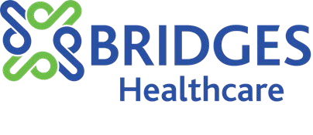

As chairperson of Bridges’ Board of Directors, it is my pleasure to announce **The Barry Kasdan Scholarship for the Pursuit of a Graduate or Undergraduate Degree in Human Services** and **The Stella Cretella Scholarship for those in pursuit of higher education through graduate or undergraduate degrees focusing on advocacy and policy reform in mental health services.** These scholarships were established by Bridges’ Board of Directors, the Board Endowment Fund Committee, and the Board Scholarship Committee in honor of Barry Kasdan’s 30+ years of leadership and service to Bridges Healthcare, Inc. and in memory of Stella Cretella’s 40+ years in advocating for mental illness health reform in Connecticut and her 10+ years serving on the Board of Directors at Bridges Healthcare, Inc.

**Mr. Kasdan** was appointed President and CEO of Bridges, then known as Milford Mental Health, in 1984. Under his leadership, the organization grew from a small mental health agency with 22 employees to an integrated healthcare system with 160 employees. Bridges Healthcare, Inc. continues to grow in size and scope serving over 8,000 area residents in Ansonia, Bethany, Derby, Milford, Orange, Seymour, Shelton, Stratford, West Haven, and Woodbridge.

**Ms. Cretella** was a firm believer in higher education, especially for women. She was a pioneer in mental health advocacy, awareness and treatment through her volunteerism on the board of directors for both Region II in Connecticut of the National Alliance of Mental Illness (NAMI) and Bridges Healthcare, Inc.

# CRITERIA FOR AWARDING THE SCHOLARSHIP

We anticipate awarding three $1,500 scholarships. The successful candidates must meet the following criteria:

1. Must be a Bridges employee, or spouse, child or grandchild of a Bridges employee, **or** a resident of Ansonia, Bethany, Derby, Milford, Orange, Seymour, Shelton, Stratford, West Haven, or Woodbridge Connecticut;
2. Must be pursuing a graduate or undergraduate degree in Human Services; or must be pursuing a graduate or undergraduate degree in Mental Health Advocacy / Public Policy; and
3. For High School applicants, must be completing high school or have GED equivalent in the year the scholarship is awarded.

Completed applications are due no later than **March 31, 2025.**

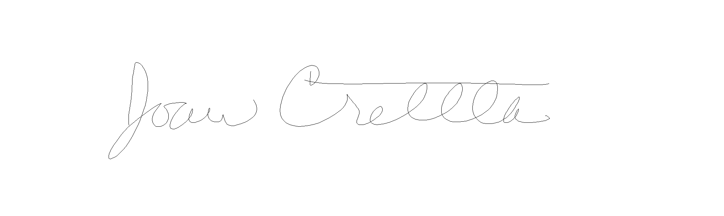Please contact [scholarship@bridgesmilford.org](mailto:scholarship@bridgesmilford.org) with any questions.

Please visit [Bridges Healthcare Board Scholarship Application](https://www.jotform.com/form/230404880253147) to complete an application.

Joan Cretella

Board Chair

Providing Behavioral Health Services to Milford, Orange and West Haven.

State Funding support from the Department of Mental Health and Addiction Services, the Department of Child and Families, the Department of Public Health, the Department of Social Services, the Department of Developmental Services and the Department of Education.

Local Funding from the City of Milford, Town of Orange, City of West Haven and the United Way of Milford.

Licensed by the Department of Public Health and Department of Children and Families, State of Connecticut. Member Agency of CommuniCare, Inc.



────

Barry Kasdan Scholarship

For those in pursuit of a graduate or undergraduate degree in Human Services.

Stella Cretella Scholarship

For those in pursuit of higher education through graduate or undergraduate degrees focusing on advocacy and policy reform in mental health services.

────

ARE YOU PURSUING A GRADUATE OR UNDERGRADUATE DEGREE IN HUMAN SERVICES?

────

Barry Kasdan Scholarship

For those in pursuit of a graduate or undergraduate degree in Human Services.

Stella Cretella Scholarship

For those in pursuit of higher education through graduate or undergraduate degrees focusing on advocacy and policy reform in mental health services.

────

**APPLY FOR A $1500 SCHOLARSHIP!**

**Requirements****.**

* + Must be a Bridges employee, or spouse, child or grandchild of a Bridges employee, **OR** a resident of Ansonia, Bethany, Derby, Milford, Orange, Seymour, Shelton, Stratford, West Haven, or Woodbridge Connecticut;
  + Must be pursuing a graduate or undergraduate degree in Human Services

# EMAIL QUESTIONS TO [scholarship@bridgesmilford.org](mailto:scholarship@bridgesmilford.org)























**Visit** [**Bridges Healthcare Board Scholarship Application**](https://www.jotform.com/form/230404880253147) **March 31, 2025.**

