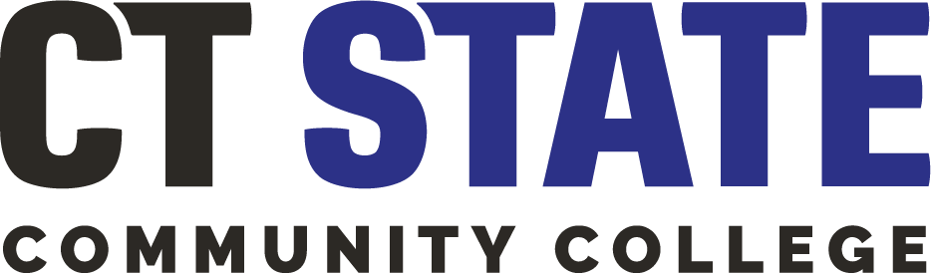

**Institutional Review Board (“IRB”)**

**CSCU Employee Statement**

As a Connecticut State Colleges and Universities (“CSCU”) employee, I, [INSERT NAME], agree not to access student or employee information maintained within any CSCU information system, including but not limited to Banner, for the purpose of conducting “[INSERT TITLE OF RESEARCH STUDY],” an external research project unrelated to my duties as a college official. Further, I agree not to seek out additional information from any CSCU information system about any student or attempt to re-identify any individual involved in “[INSERT TITLE OF RESEARCH STUDY]” research study.

Signature:

Date: